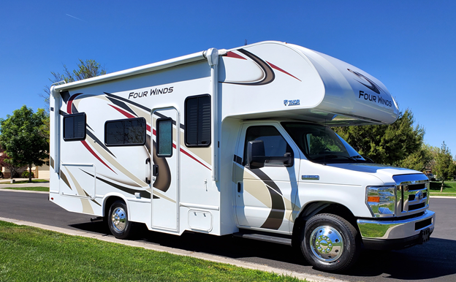
Welcome to
“Minnie”
Operator’s Manual
2023

Table of Contents
Adventure Is Calling RV Rental
www.Adventureiscalling.us
295 E. Eldorado Lane
Las Vegas, NV 89123

Mike 702-881-3821
Lisa 702-373-3907

Item Description Page #
Welcome ……………………………………………………………………………………………………. 3
Picking up the RV ………………………………………………………………………………………… 3
Keys ……………………………………………………………………………………………………………. 4
RV Control Panel ………………………………………………………………………………………… 5
Generator ………………………………………………………………………………………… 5
Holding Tanks …………………………………………………………………………………… 6
Water Pump ……………………………………………………………………………………… 6
Hot Water Heater ……………………………………………………………………………… 6
Thermostat for Heater and AC ……………………………………………………………………. 7
Smoke Detector and Carbon Monoxide/Propane Detector …………………………. 7
Kitchen Appliances ……………………………………………………………………………………… 8
Refrigerator ………………………………………………………………………………………. 8
Stove and Oven ………………………………………………………………………………… 8
Microwave ……………………………………………………………………………………….. 9 Kitchen lights and Exhaust Fan …………………………………………………………………... 9
TV, DVD Player and Remote ……………………………………………………………………….. 9
Exterior Compartments ………………………………………………………………………………. 10

Getting to your Campsite with Hookups:
Hooking up to RV Camp Electricity …………………………………………………… 12
Hooking up to RV Camp Water ………………………………………………………… 12
Hooking up to RV Camp Sewer ………………………………………………………… 12

Leaving Your RV Campsite:
Disconnect from RV Camp Water ……………………………………………………... 13
Dump Black and Gray Holding Tanks …………………………………………………. 13
Flush Black Tank ……………………………………………………………………………….. 13
Disconnecting from RV Camp Electricity ……………………………………………. 14
Leaving your campsite ……………………………………………………………………… 14

Returning the RV: ………………………………………………………………………………………. 14

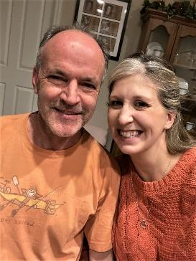
Welcome! We are Michael and Lisa O'Dowd. We call Henderson, NV, home but come from Colorado and Chicago. We love to go camping with the family enjoying wonderful places throughout the western United States. We have six children and having an RV has helped us feel relaxed, comfortable, and safe while experiencing the great outdoors. Our hope is that you will experience the same on your trip!

The purpose of this manual is to help you understand the basic operations of the motorhome. If you have any questions during your trip, experience any difficulties, or get in an accident, please call us at 702-881-3821 or 702-373-3907.
Picking up the RV: Several days before your trip, we will reach out to confirm the pick-up date, time and location. Please allow at least one hour for a walk through of the RV, completion of an inspection checklist, completion of any paperwork and a question-and-answer time for you. After that, we hand you the keys and you are on your way!
If during your trip you want to extend your rental, you must call and verify availability, as another family may be waiting to start their adventure.


KEYS:
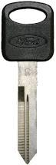
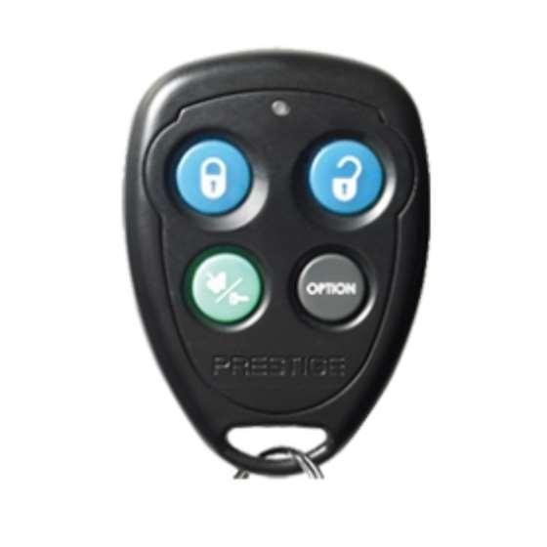
The key fob (if available) only locks and unlocks the two cab doors. The long skinny key is the ignition key.

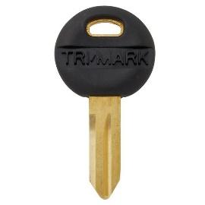
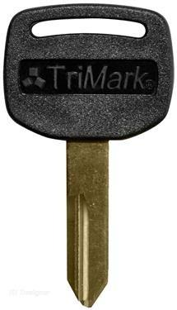
The fat gold key locks and unlocks the top lock on the camper door. This top lock is a deadbolt. The smaller round key locks and unlocks the bottom lock on the camper door. This locks the handle in place.

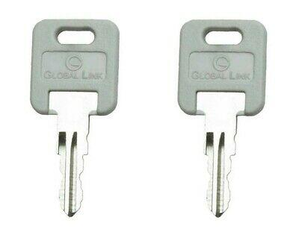
The key with a square, gray colored top is used to open all the compartments on the exterior of the RV. When the key hole is up and down, the compartment door is unlocked. When the key hole is side to side, the compartment door is locked.
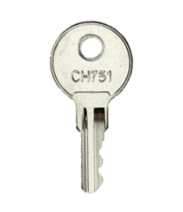

The final key is a silver key. This key unlocks the exterior shower.

You will receive one set of keys for the RV. A lock box with a combination lock is provided with an extra ignition key and exterior compartment key in it. If you lose a set of keys, you can use the lock box keys to gain access to the motorhome, drive the motorhome and access all exterior compartments.
A lost set of keys will result in a $200 fee assessed against your security deposit.

RV Control Panel:
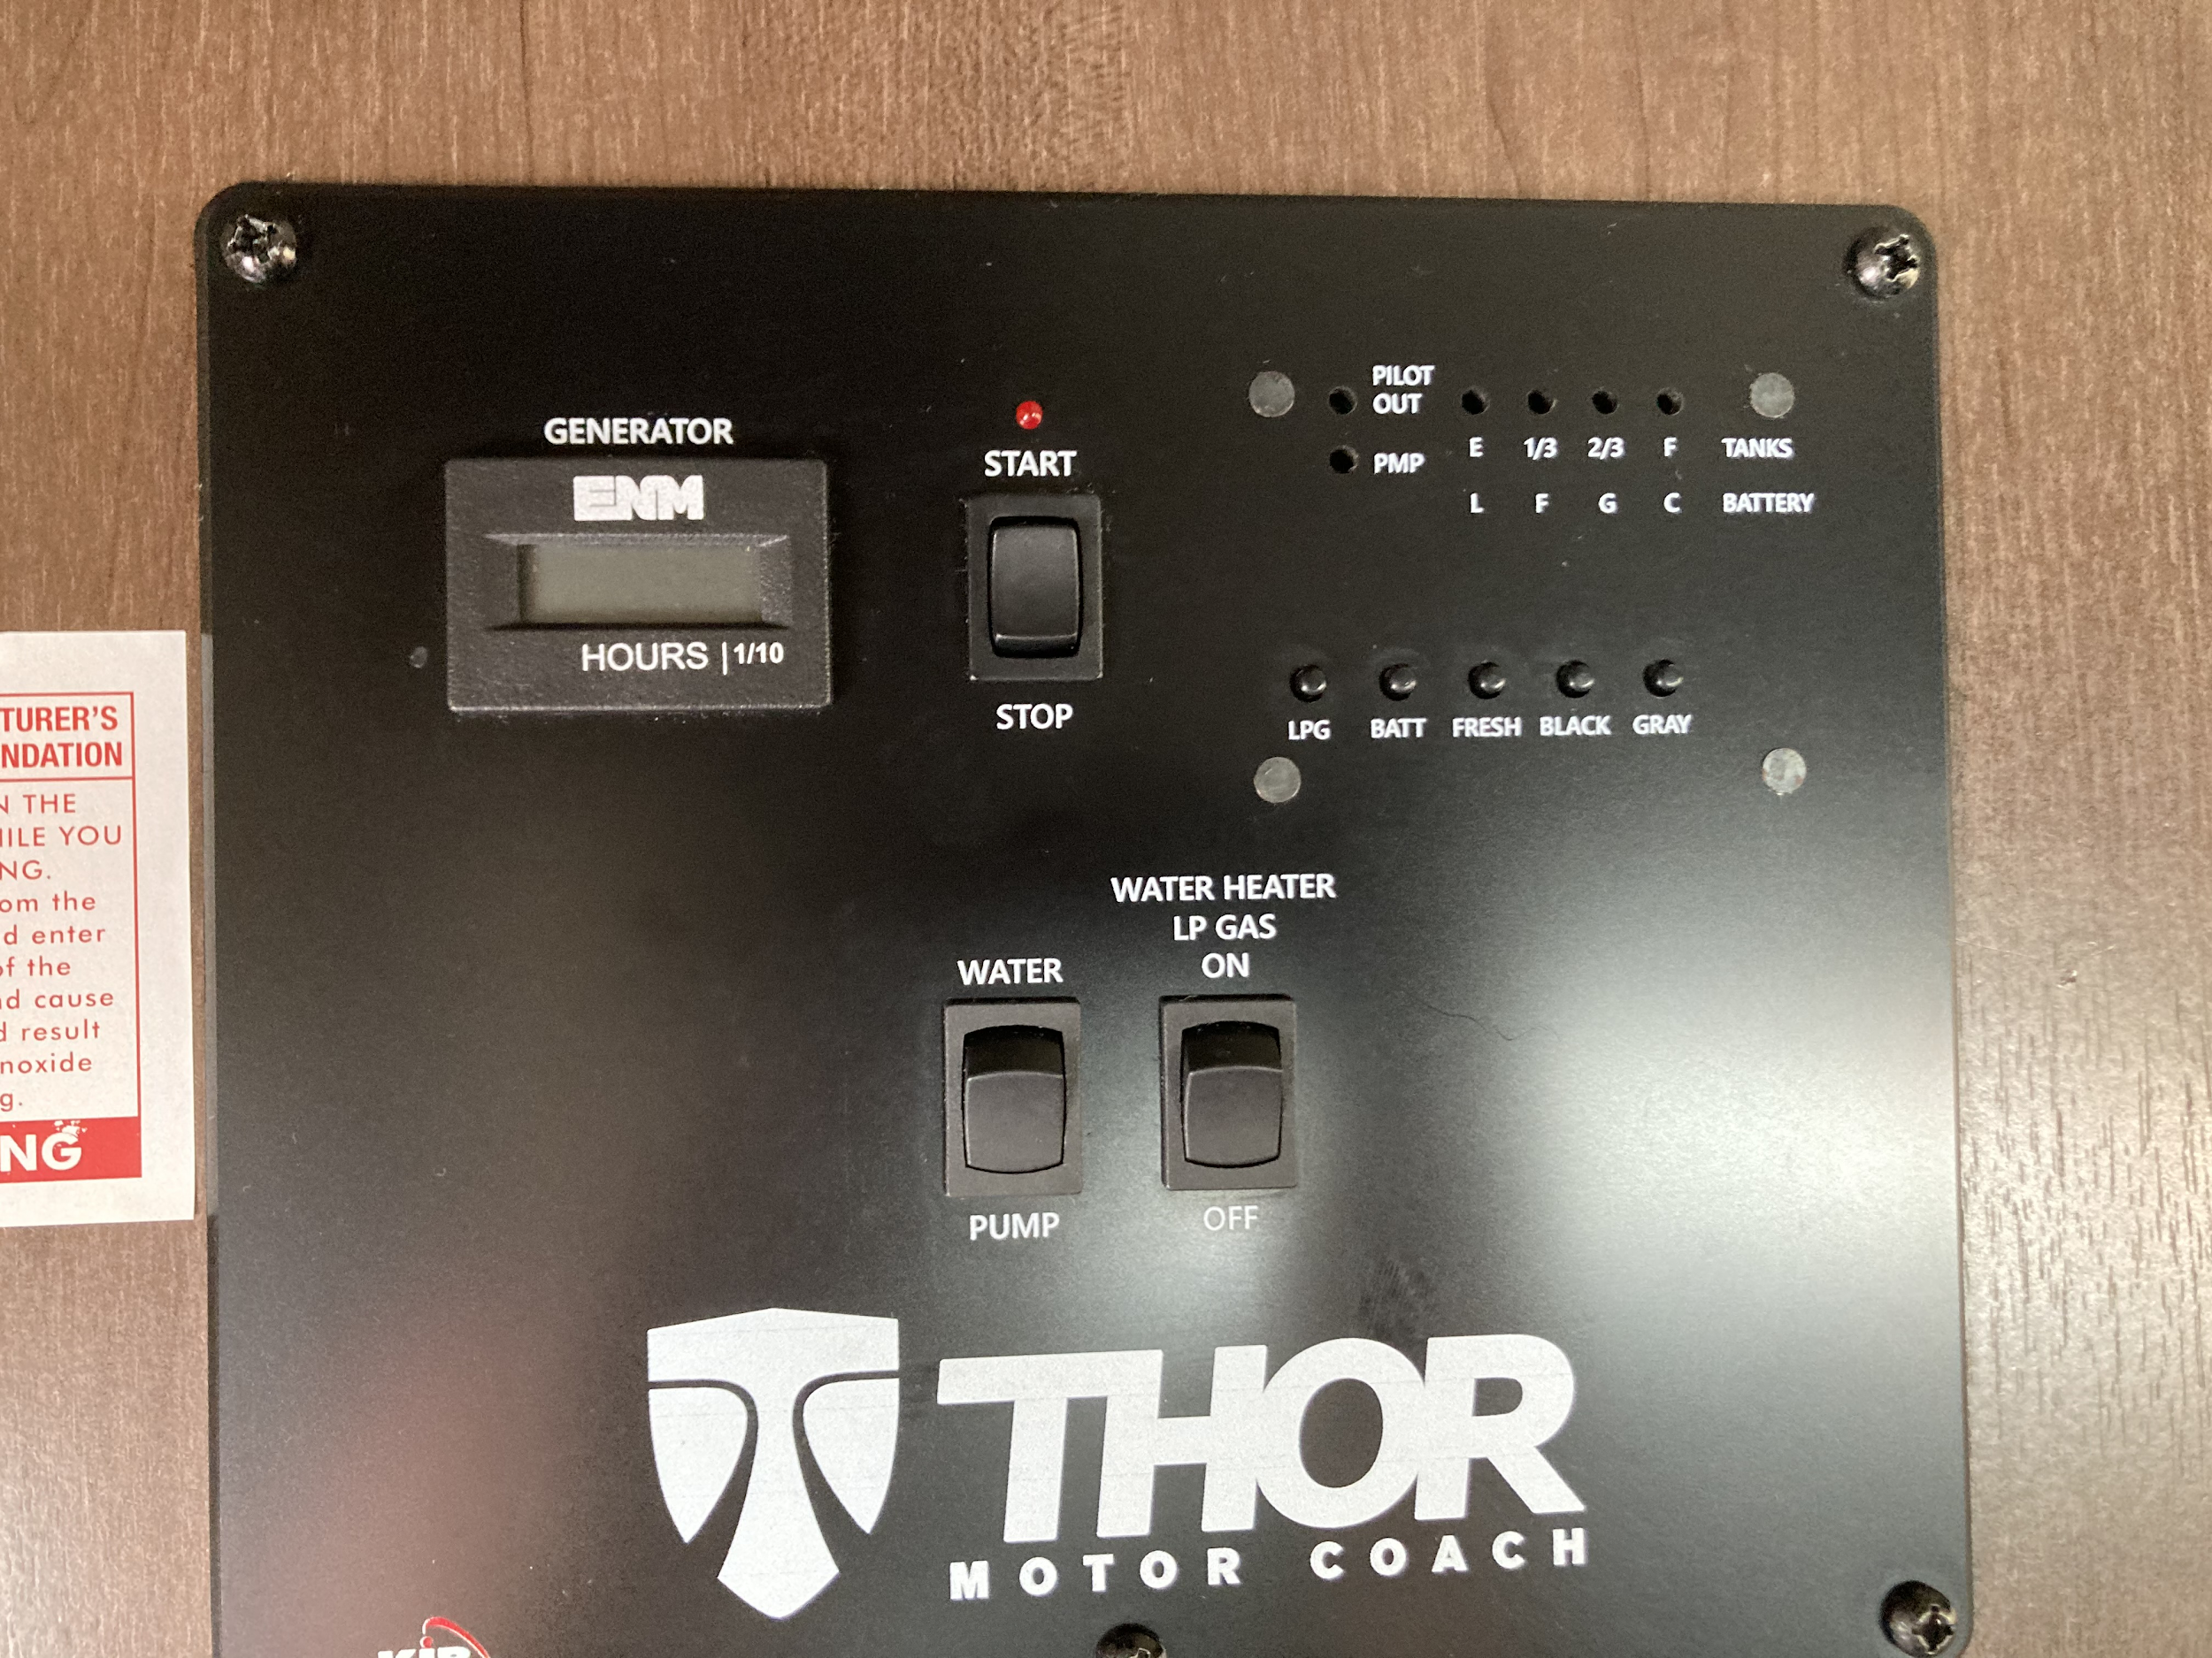

1
2

3

Generator:
#1 and #2 are for the generator. This is where you start the generator. You do not have to go outside to the generator compartment, simply start it from inside the RV. To start the generator, press the “Start” button and hold it down. If it is warm outside, it will start up quickly, if it is cold, it may take 10-15 seconds. If it does not start in 15 seconds, the unit will shut down. Let it rest for thirty (30) seconds and start over. The red light next to the word “Generator” will flash while trying to start and will be lit when the generator is running. The generator runs off the truck’s gas tank. If the gas tank gets to ¼ tank, the generator will not run leaving you ¼ tank to run the truck’s motor and drive to a gas station. Do not run the generator while you are sleeping.
#2 is the generator’s hour meter. If you start the generator at hour 51 and turn it off at hour 53, you used the generator for two (2) hours. Remember you get three (3) free hours of generator use each night you rent the RV. If you rent the RV for five nights, you will get 15 free hours of generator use. Anything over that will be charged $4.00 an hour. There is no refund for unused hours.

Holding Tanks:
The red box area labeled #3 is for the RV’s Holding Tanks. The four red lights at the top tell you how full or empty each tank is. 1 light = empty or very low. 2 lights = 1/3 tank, 3 lights = 2/3 tank, 4 lights = full. Each button underneath the lights is for each tank.
- LPS button is for Propane Tank 9.6 gallons
- Batt is for RV battery, not truck battery. These are separate.
- Fresh is for freshwater tank
- Black is for Black Tank – this is anything flushed down the toilet.
- Gray is for Gray Tank – this anything that goes down the drain of the sink or indoor shower.
Please remember to dump both the Black and Gray Tanks before returning the RV. Not emptying either or both tanks will result in a $50 fee being assessed against the Security Deposit.

Water Pump:
The Water Pump button is used to operate the “Water Pump.” The water pump is only used when not hooked up to a water source and you need water in a sink or the toilet. Push the button up to turn the water pump on. When done with the water, turn the water pump off. The red light labeled PMP tells you the water pump is on when lit.

Hot Water Heater:
The last box shows the Hot Water Heater. Use the button to turn the hot water heater on using propane. If the light marked “Pilot OUt” is lit, the pilot for the hot water heater is out. Turn the LP Gas Button OFF.

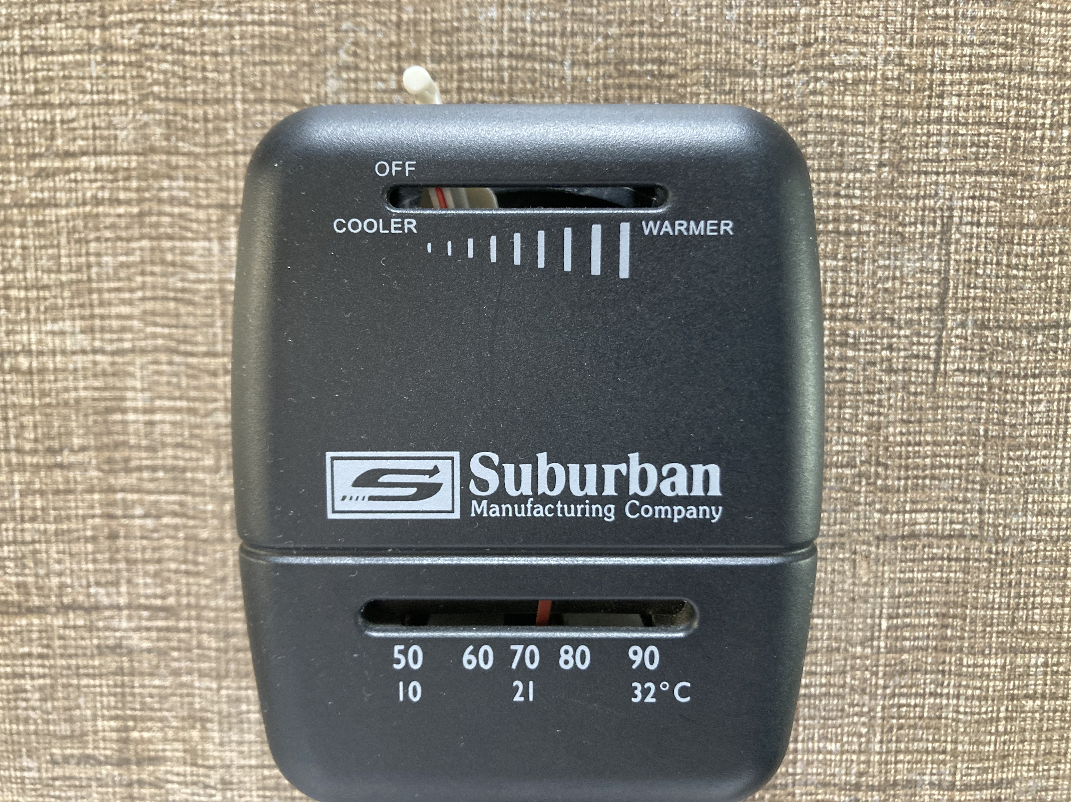
Thermostat for RV Heater:
The thermostat is located on the wall by the master bed. Simply move the switch at the top away from off to the desired spot. The heater will turn on. The gauge at the bottom tells you the air temperature. Adjust the top lever as necessary. When done with heater, be sure to turn top lever to the “Off” position (to the far left),

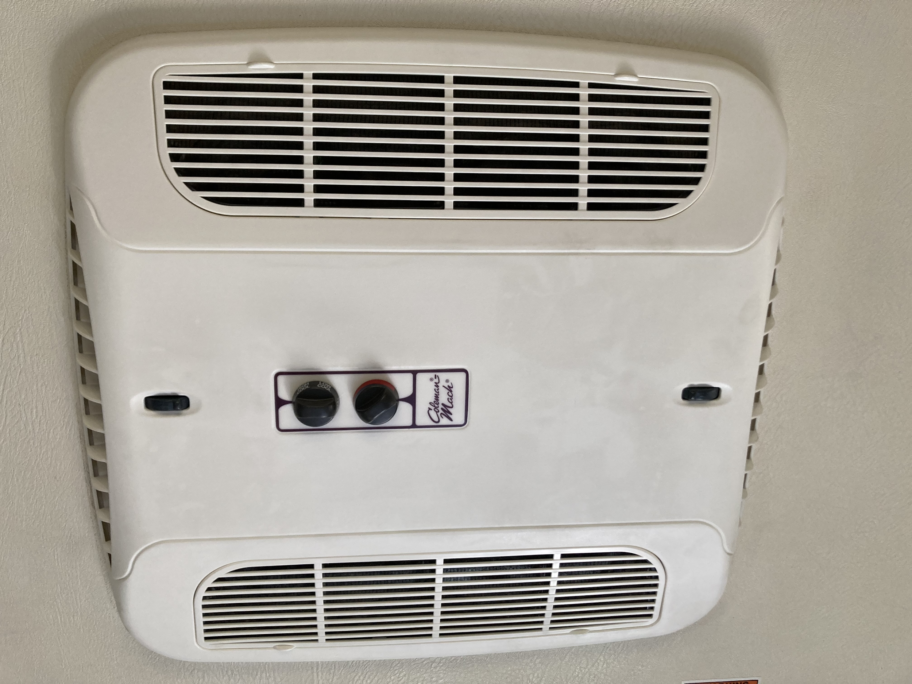
RV Air Conditioner: The Air conditioner is located on the ceiling of the RV. The knob on the right turns the unit on - fan (high or low) and AC (high and low). The knob on the left controls the temperature range. All the way blue = coldest. The rolling dials on each end open and close the vents. The vent on the right cools the cab-over bed, the vent on the left cools the kitchen and master bed area. You can run the RV’s AC while driving by running the generator. After starting the generator, wait a minute or two before turning on the AC.

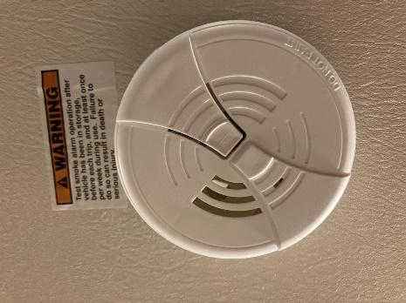
Smoke Detector:
The RV has a smoke detector on the ceiling above the dinette. It is located in the center of the RV and can easily be heard throughout the RV.

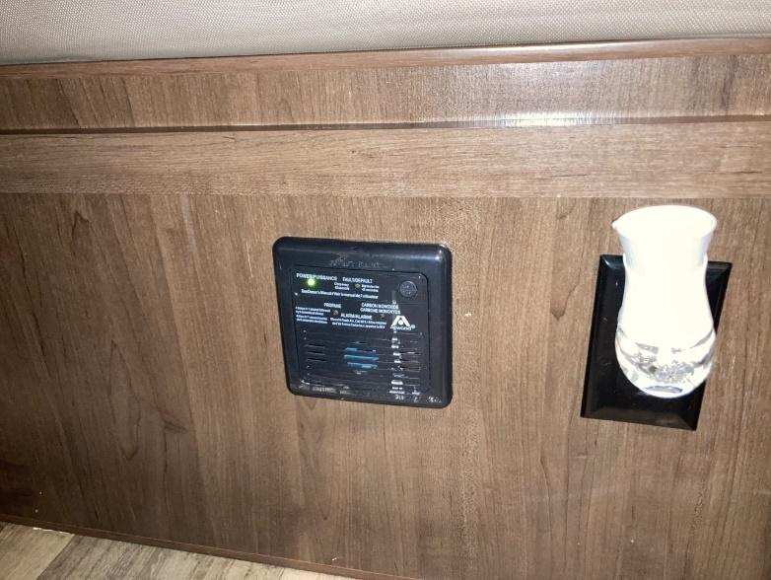
Carbon Monoxide and Propane Detector:
The RV has a Carbon Monoxide and Propane gas detector located under the dinette table. Four (4) beeps sound in one second and then there is five (5) seconds of silence, and then four (4) beeps sound, etc. If you hear this sound, make sure the gas on the stove/oven is turned off and move outside to fresh air. If after letting the RV air out the alarm is still beeping, push the reset button. If the alarm continues to sound, call 911, move away from the RV, and get fresh air.

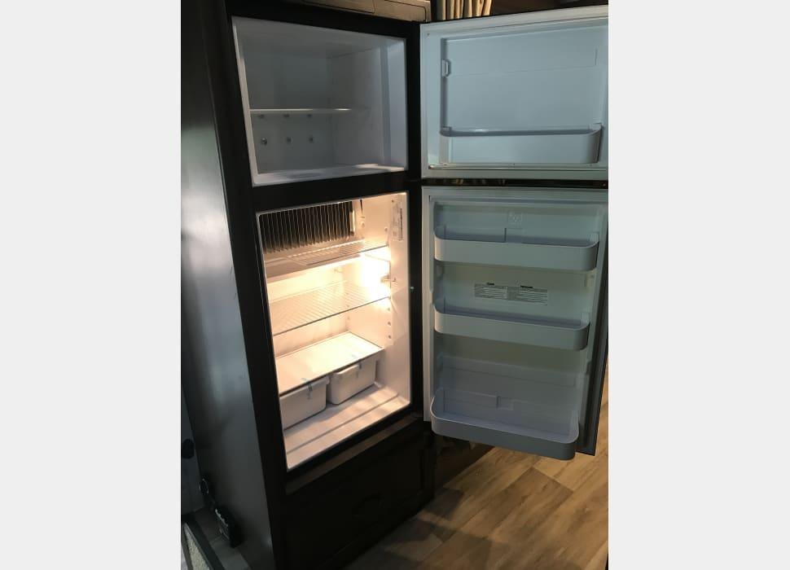
Kitchen Appliances:
Refrigerator & Freezer: This RV comes with a mid-size refrigerator/freezer. The refrigerator is 6 cubic feet and the freezer is 2 cubic feet. The refrigerator can run off electricity or propane. If you leave the controls on “Auto,” the refrigerator will switch over from one to the other when you are plugged into electricity or not.
We will turn the refrigerator on 1 day prior to you picking up the RV so the refrigerator and freezer are cold when you pick it up.
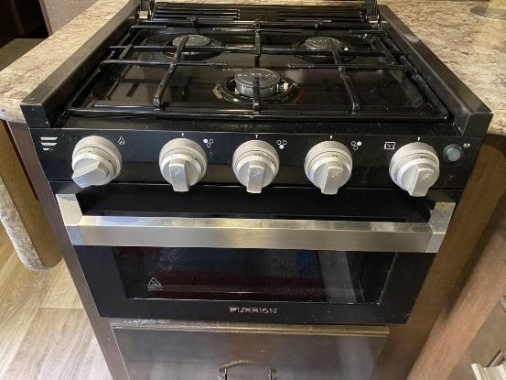
Stove and Oven: A three burner gas stove is provided. A set of pots are located in the drawer below the oven. To light a burner, turn the knob for the desired burner to the flame icon (the first picture on each knob), and turn the ignitor knob on the far left. Adjust the flame using the burner knob to your desired setting. To light the oven, open the oven door and peer inside below the shelf. Push the oven knob (knob on far right) in and turn to the flame icon. Light the pilot using a long lighter (provided). Once the pilot light stays lit, turn the oven knob to the desired temperature. When done with a burner or the oven, be sure to turn each knob completely off. A cookie sheet is provided inside the oven. Be sure to remove the cookie sheet before lighting the oven.

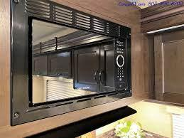
Microwave: A microwave oven is also provided for you. You can use the microwave while driving or not plugged into electricity at your campsite by running the generator. Once the generator starts, wait a minute or two before using the microwave. Using the microwave while plugged in to electricity at a camp site does not require the use of the generator. Be sure to use microwave safe dishes and containers in the microwave. Do not use the blue metal plates, bowls or cups in the microwave.

Kitchen Lights and Exhaust Fan: The switches for the kitchen lights and exhaust fan are located under the cabinet right above the sink. The exhaust fan is in the ceiling vent. Be sure to remove the sunblock cushion before running the exhaust fan and be sure to open the vent using the black turn knob.

TV, DVD and Remote Control:
There is a TV and DVD player provided for your entertainment. The TV is located in the cab over bed area and is on a swing mount. The TV can be visible by people on the cab over bed or turned for people in the main living area. The DVD player is mounted beneath a cabinet to the right of the TV. There is a remote control for both the TV and DVD player velcroed to the cabinet.

Exterior Compartments:
Passenger Side:
To the right of the RV door is the Propane Tank compartment. This is where you fill the propane tank at the end of your trip before bringing it back to us.
At the rear of the RV is a large compartment. This is where you will find:
- 4 Camping Chairs
- Leveling Blocks
- Sewer hose, sewer elbow, and disposable gloves
- Water hose for RV and pressure regulator
- Spare tire
- Small folding table (48” x 24”)
- Extension cord

Getting to your Campsite with Hookups:
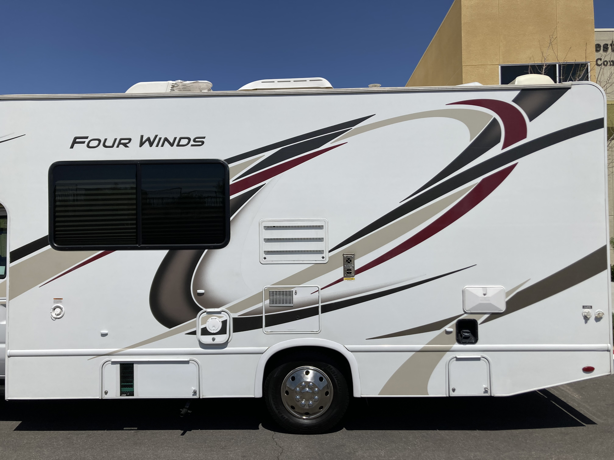

1

2 3 4 5 6 7 & 8

- Fresh Water Holding Tank Input.
- Generator compartment
- Electrical Cord Box - Plug this into your RV Campsite (30 amps) to run all electrical functions of RV.
- Exterior shower
- Truck’s fuel tank - Unleaded fuel only
- Sewer connection
- Fresh Water Connection - Hook hose here and to campsite faucet for a direct line of water to RV
- Black Tank Flush Hook Up

Male-end Female-end

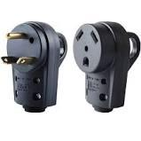
Connecting the RV to the Campsite Electricity:

The RV comes with a 30 ft. heavy duty electrical cord to connect the RV to the power source provided at the campsite. The RV requires a 30-amp outlet. The female end is connected to the RV’s electrical box. Plug the male-end into the outlet provided at the campsite.

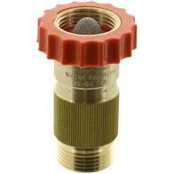
Connecting the RV to the Camp Site Water Supply:
Look for a white water hose and blue water filter stored in a gray bin in the biggest storage compartment toward the rear of the RV (passenger’s side). The bin will be labeled, “Water Bin.” Connect the male end of the garden hose to the Fresh Water Hose Connection on the RV. Connect the female end to the water supply at the campsite. Make sure a Water pressure regulator is connected between the camp site’s water supply and the white hose. (These are usually provided by the campsite and already connected to the water faucet. If a water pressure regulator is not provided by the camp, one is provided in the Water Bin.) If you do not use a water pressure regulator, the water pressure may cause damage within the RV water system. Finally, turn on the water from the campsite faucet.
Water pressure regulator

Connecting the Sewer Hose from the RV to the Campsite Sewer Supply: Look for a sewer hose stored in a a bin labeled, “Sewer Bin” or inside of the square back bumper. Remove the black lids from both ends of the sewer hose. Remove the cover from the sewer pipe on the RV. Connect the sewer hose to the sewer pipe. Extend the hose long enough to reach the sewer outlet at the campsite. Install the clear elbow into the sewer outlet at the campsite and connect the other end of the sewer house to the elbow.

It is best to leave the black and gray holding tanks closed until you are ready to “Dump.” If you leave the valves open, you may get a sewer smell in the RV.

Leaving Your RV Campsite

Disconnect from RV Camp Water: Turn off the campsite water faucet. Disconnect the white hose from the faucet. (Be careful, water might spray all over the place as you unscrew the hose.) Disconnect the white hose and blue filter from the RV. coil the hose and connect the two ends together so nothing gets in the hose. Put the coiled hose and filter back in the tub marked, “Water Bin.”

Dumping Black and Gray Holding Tanks & Flushing the Black Tank: Locate the “Sewer Bin'' in the biggest storage compartment toward the rear of the RV (passenger’s side). You may want to put on a pair of disposable gloves (provided in the Sewer Bin). Make sure the sewer hose is properly connected (see above). Pull the black handle and let the waste from the toilet empty first. When it sounds like it is done draining, pull the gray handle to let the waste from the sinks and shower drain.

While the gray tank is draining, hook the gray colored hose from the “Sewer Bin'' up to the campsite water faucet and the other end to the “Black Water Tank Flush” or “Sani-Flush Connection” on the RV (#8 pictured above). Push the black handle back in to close the valve to the Black Holding Tank. Turn the campsite water faucet on and you will hear water running into the Black Holding Tank. This is ”Flushing the tank.” After 2-3 minutes. Turn the campsite water faucet off. Pull the black handle to drain the Black Holding Tank a second time. When done draining, push both the black and gray handles in to close both valves.

Disconnect the sewer hose from the RV. Rinse the sewer hose out using the gray colored hose and leaving the sewer hose connected to the campsite sewer line. When done, turn off the campsite water and disconnect the sewer hose from the campsite sewer connection. The sewer hose collapses like an accordion. Replace black lids on both ends of the sewer hose. Store the sewer hose back in the “Sewer Bin.” Disconnect the gray hose, coil it up, and store. Replace the sewer pipe cap on the RV’s sewer pipe. Lock up the sewer compartment door on the RV. You are all done!!!

Disconnecting from RV Camp Electricity: Before unplugging the RV’s power cord, make sure the AC unit is turned off. Disconnect the back cord from the campsites electrical box. Coil the cord and store in the RV’s electrical cord compartment.

Leaving Your Campsite: Make sure the awning is retracted all the way until it is touching the motorhome. Look around the campsite and make sure you retrieved all your stuff. Look under the motorhome to ensure you don’t run anything over. Be sure you have checked out of the RV office, and head out!!!

Returning the RV: Before meeting with Mike and/or Lisa to return the RV, make sure:
- You have filled the Fuel Tank. If the Fuel Tank is not full, you will be assessed a $5.00 per gallon fee to get the tank to full.
- You have filled the Propane Tank. If the Propane Tank is not full, you will be assessed a $5.00 per gallon fee to get the tank to full.
- You have emptied both the Black and Gray Holding Tanks. If one or both Holding Tank(s) has/have not been completely emptied, you will be assessed a $50.00 fee.
- You have cleaned up after yourself.
  - Sweep the floor (broom located in bathroom)
  - Wipe down counters and table (Windex under sink and paper towels provided)
  - Remove all trash
  - Remove all personal belongings
  - Ensure all dishes and pots are washed
  - Ensure the refrigerator and freezer are empty.

If the RV is excessively dirty, you will be charged an additional $100 cleaning fee.


Add-On Items


Thank you for renting an RV with us. To enhance your trip, we offer the following add on items to help you and your family enjoy your Adventure even more! All of our add on items are subject to availability on a first-come, first-served basis.

Please email for availability at:
info@adventureiscalling.us

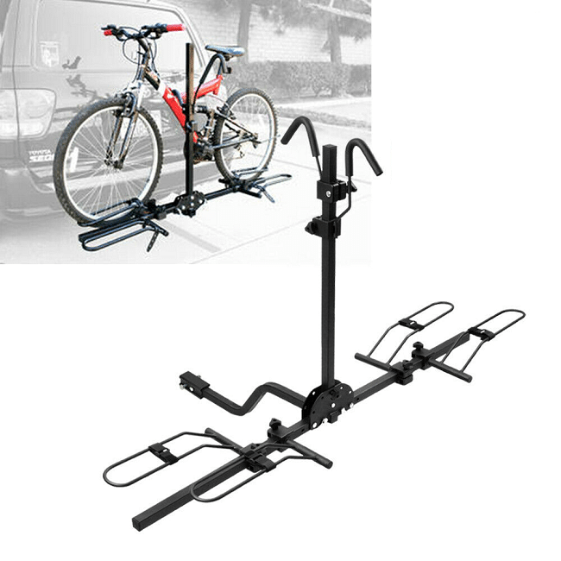
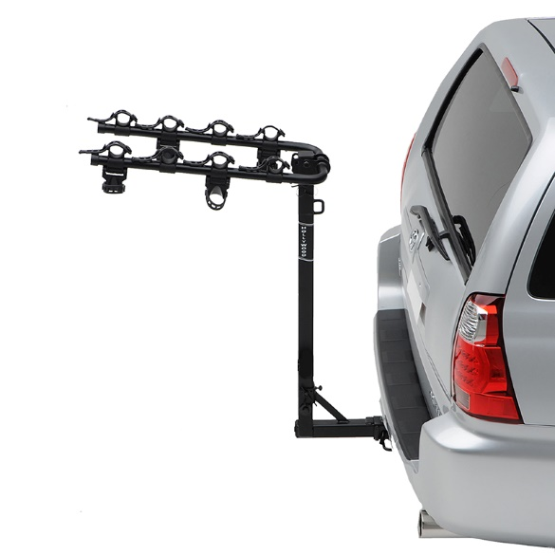
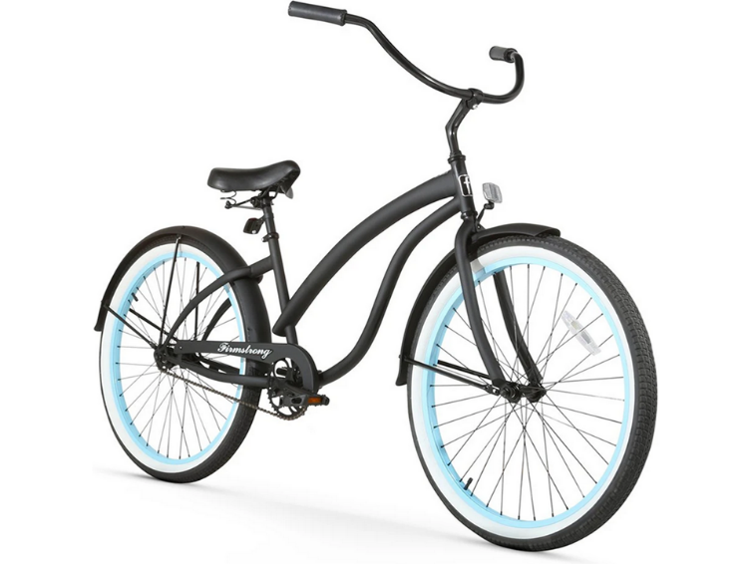
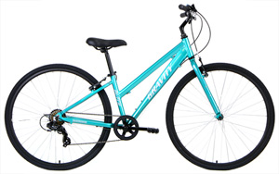
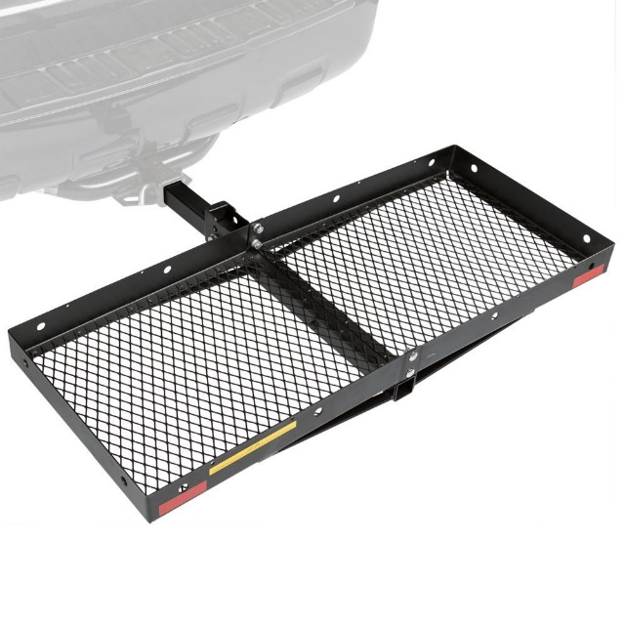
Bikes and Bike Racks
For the active explorers, we offer Beach Cruisers and Mountain Bikes. We have bikes for men, women and teen. We also offer a way to bring those bikes along. Two different styles of bike racks. Listed below are the costs for each item.
Bikes: $5 each per day
Bike Rack: $10 (flat rate)

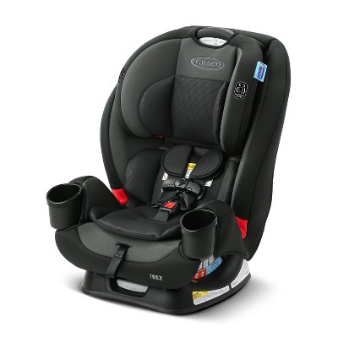
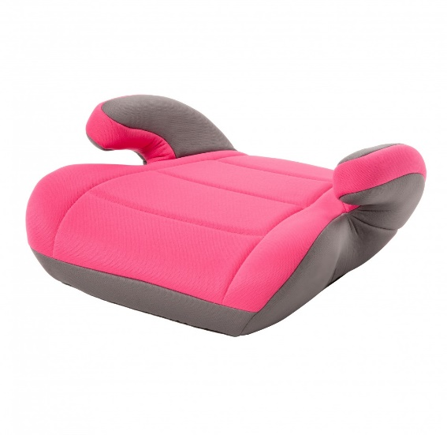
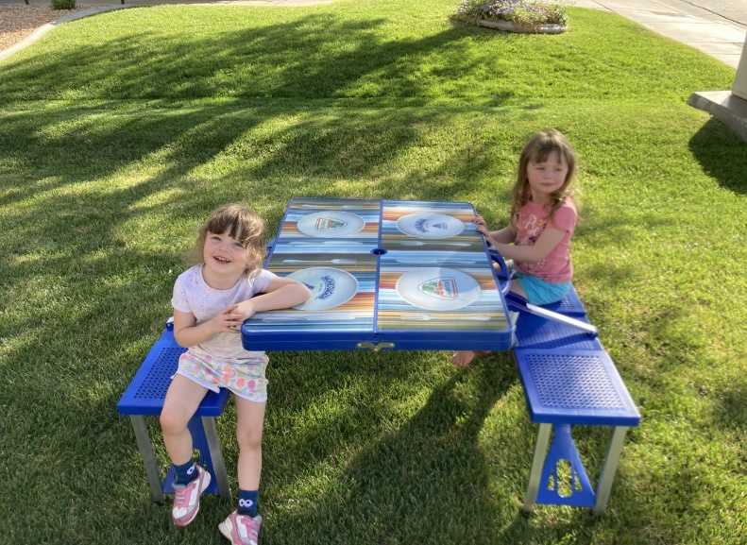
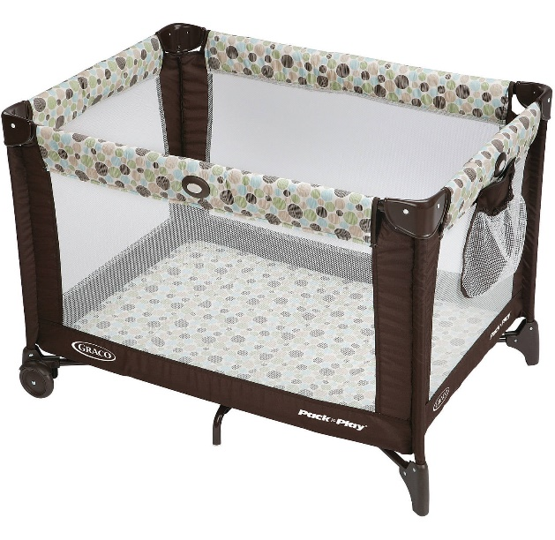
Small Children Items
Travelling with littles? We have them taken care of too! No need to lug heavy car seats through the airport, and no need to worry where baby is going to sleep in the RV’s. We even can add a touch of fun to eating outside, not to mention extra room for adults with our child size picnic table!
Picnic table: $5 flat rate
Pack N Play: $10 flat rate
Car Seat: $10 flat rate
Booster Seat: $5 flat rate

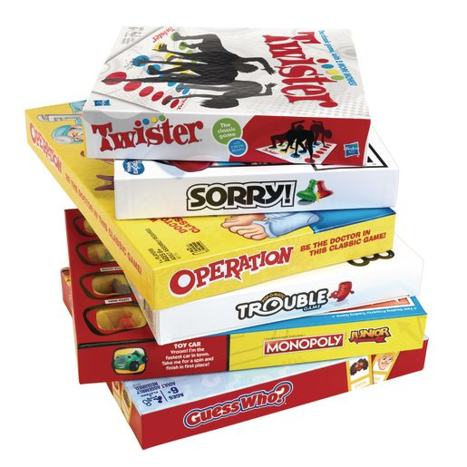
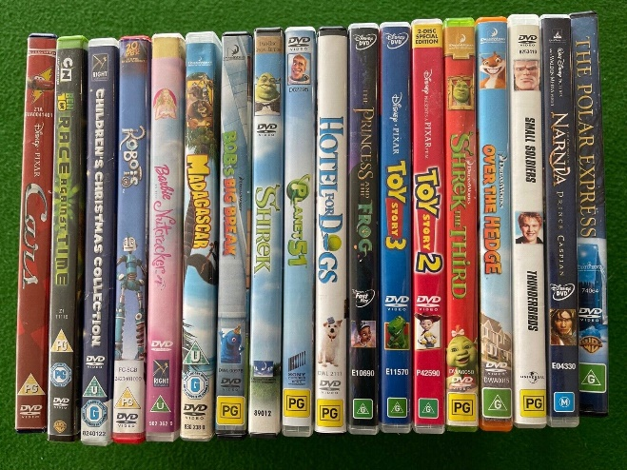
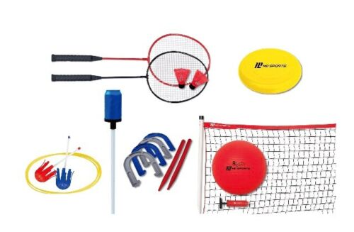
Games and Movies
Bad weather? No worries, we offer a wide variety of family friendly movies, and board games. Good weather? Get outside and play with our array of outdoor game sets like croquet, badminton, footballs (and others), bocce ball and many more!
Croquet set: $10 flat rate
Two Movies: $5 flat rate
Two Board Games: $5 flat rate
Outdoor playsets: $7 flat rate

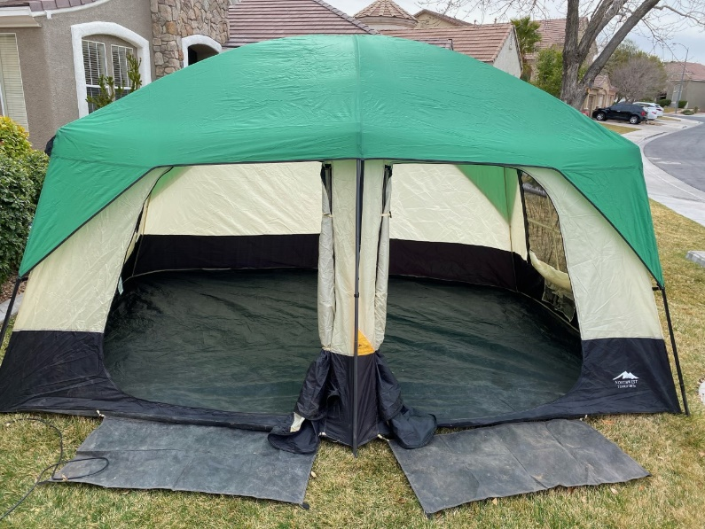
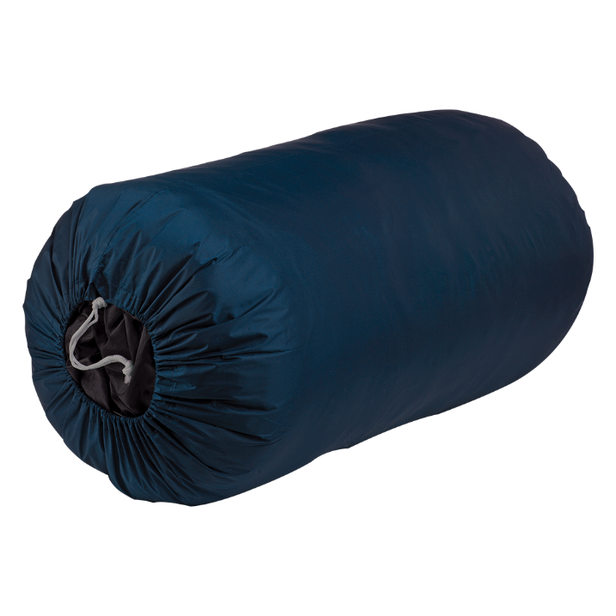
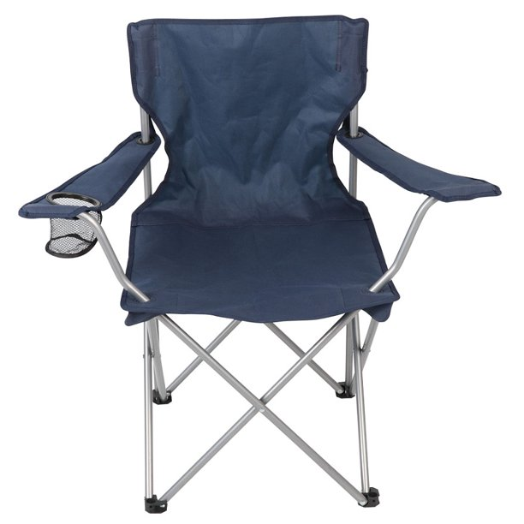
Camping Add-Ons
Need extra space or have guests? Why not rent our two-room 8 person tent, and allow your friends or kids to get the true camping experience. Along with our big tent, we do have a smaller 4 person tent. We also have sleeping bags and extra camping chairs for even more space and seating.
One additional Camping Chair: $5 (each) flat rate
(4 chairs come with rental)
Sleeping bag: $5 flat rate
4 person Tent: $10 flat rate
8 person tent: $15 flat rate

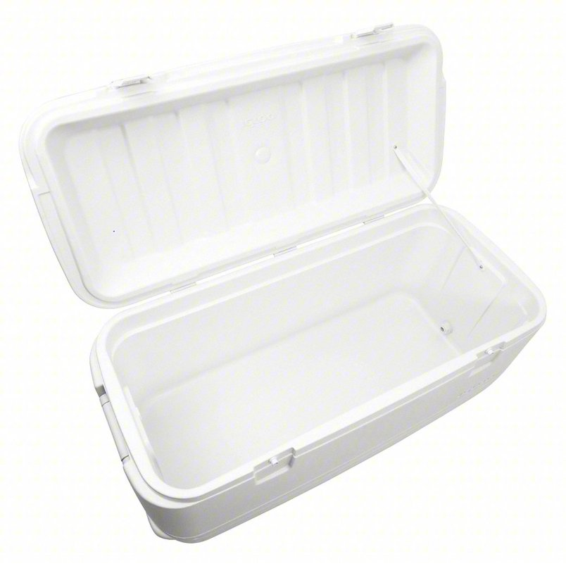
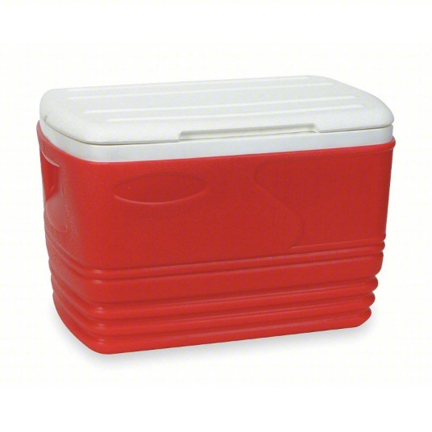
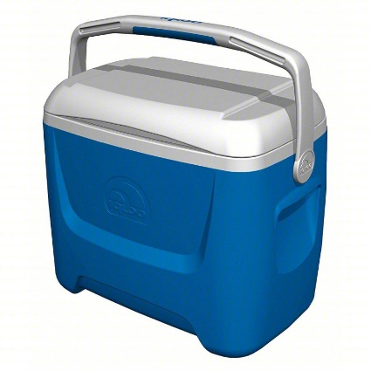
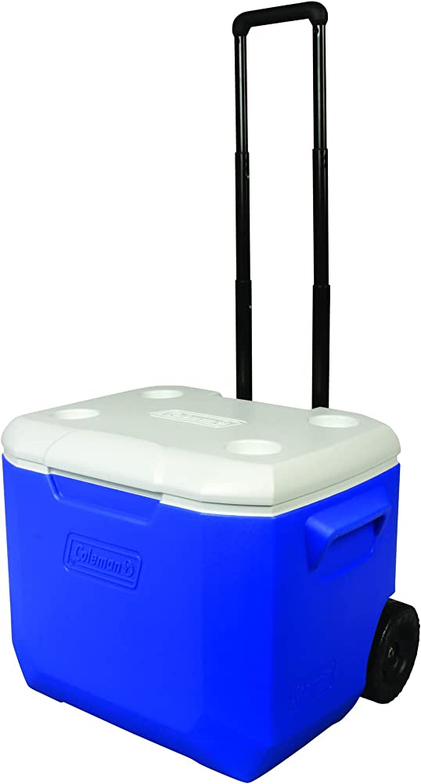
Cooler Add-Ons
RV refrigerators don’t always have adequate space for all your cooking needs. Why not add on a cooler to help bring along all your favorite meals and snacks. We have several sizes available.
Large (36in x 14in x 15in): $20
Medium (27in x 14in x 14in): $15
Wheeled Small (16in x 10in x 15in): $10
Small (16in x 10in x 15in): $10

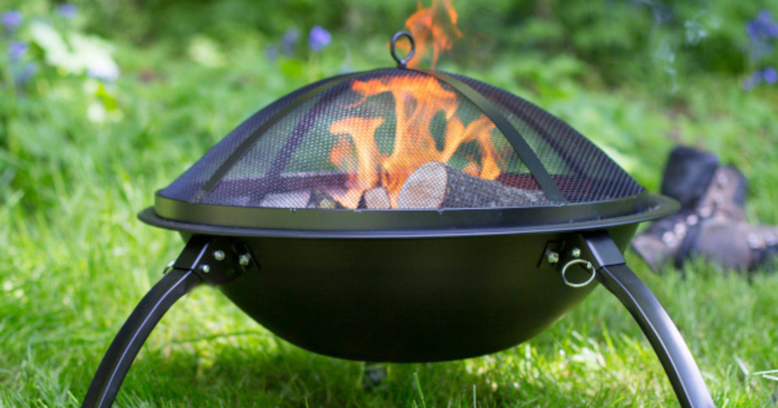
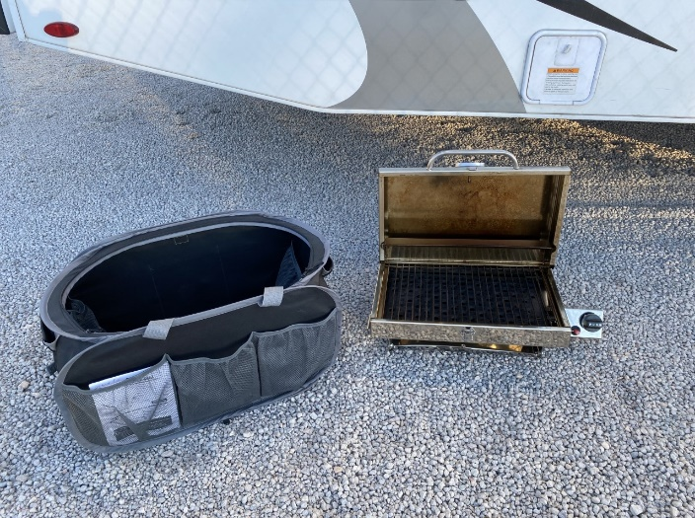
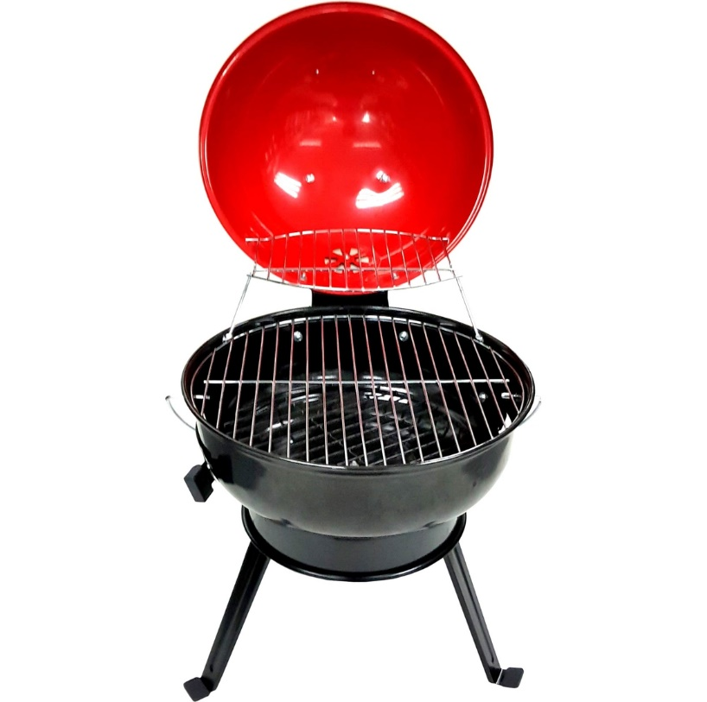
Grilling Add-Ons
What’s camping without camp fires and outdoor cooking. With these add on packages, you can do both! Our grill package includes: grill, a bucket of matchlight charcoal, lighter fluid and grill utensils. The fire pit package includes: Fire pit, 10 pieces of firewood, and a small axe. These items must be returned clean or there will be $20 fee for cleaning.
Fire Pit package: $25 flat rate
Grill Package: $25 flat rate
Propane Grill: $25 flat rate (small propane tank not included)

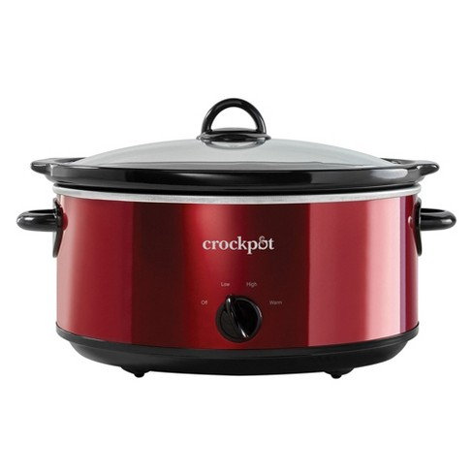
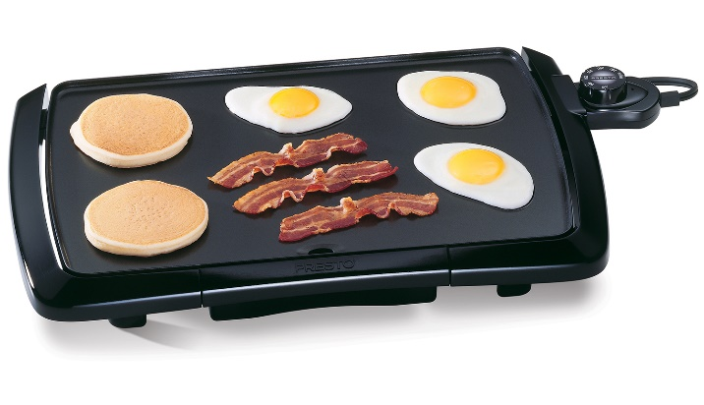
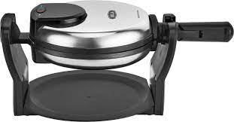
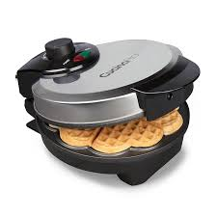
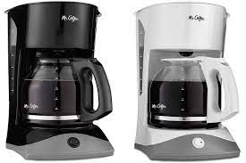
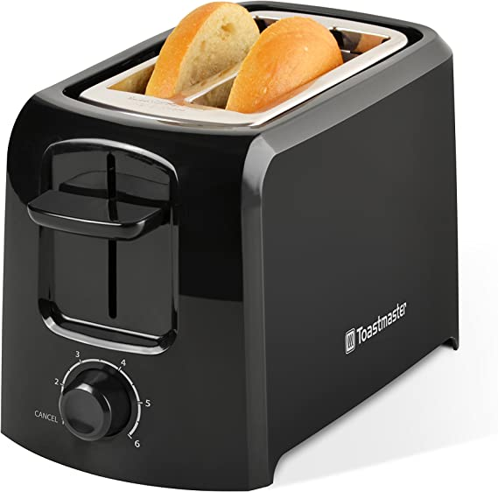
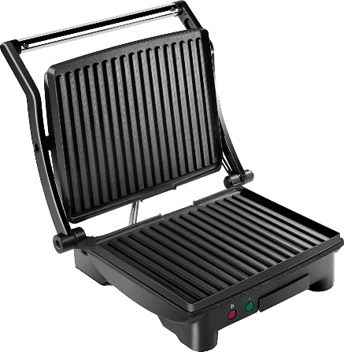
Cooking Add-Ons
MMM, bacon! Everyone loves the smell of bacon in the morning. These add on items allow you to have all your favorite breakfast food items including coffee! There is nothing better then prepping dinner and leaving to hike for the day and coming home to a fully cooked meal in the crock pot!
Toaster: $5.00 flat rate
Coffee Pot: $5.00 flat rate
Electric Griddle: $5.00 flat rate
Crock Pot: $5.00 flat rate
Panini Maker: $5.00 flat rate
Waffle Maker: $5.00 flat rate

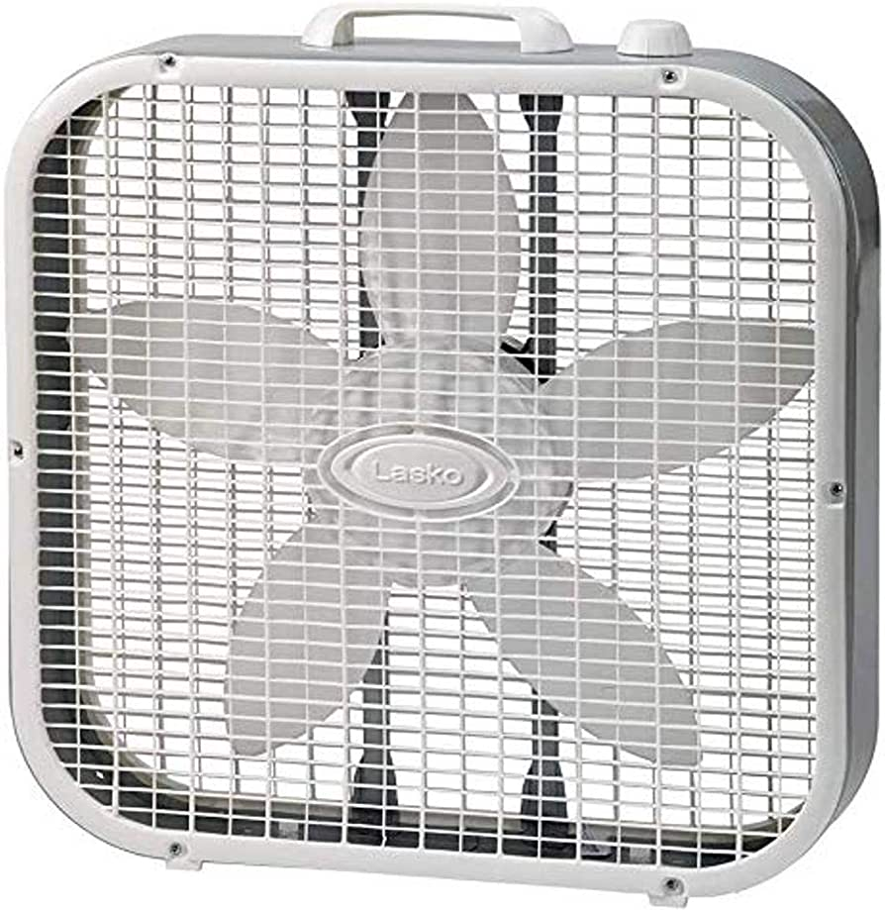
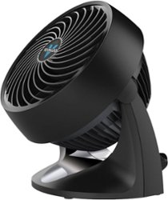
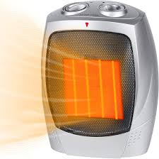
Heat/AC Add-Ons
When it comes to extreme weather, summer or winter. It is always nice to have a little extra help cooling down your unit or heating it up. These little add-ons, add so much to your trip! Making the inside of the RV just as enjoyable as the outside!
Large Box Fan: $5.00 flat rate
Small Fan: $5.00 flat rate
Space Heater: $5.00 flat rate
Small Box Heater: $5.00 flat rate

