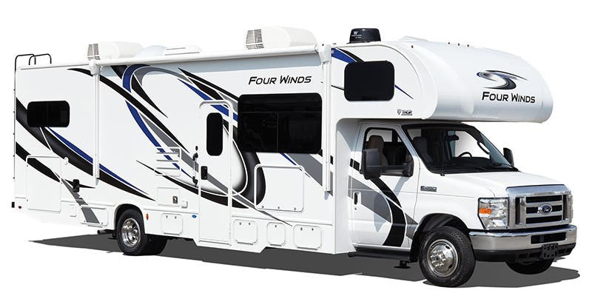

Welcome to
“Maverick”

Operator’s Manual
2023

Adventure Is Calling RV Rental
www.Adventureiscalling.us
295 E. Eldorado Lane
Las Vegas, NV 89123

Mike 702-881-3821
Lisa 702-373-3907

Table of Contents
Item Description _ Page #
Welcome ……………………………………………………………………………………………………. 3
Picking up the RV ………………………………………………………………………………………… 3
Keys ……………………………………………………………………………………………………………. 4
RV Control Panel ………………………………………………………………………………………… 5
Generator ………………………………………………………………………………………… 5
Holding Tanks …………………………………………………………………………………… 5
Water Pump ……………………………………………………………………………………… 6
Hot Water Heater ……………………………………………………………………………… 6
Thermostat for Heater and AC ……………………………………………………………………. 7
Smoke Detector and Carbon Monoxide/Propane Detector …………………………. 7
Kitchen Appliances ……………………………………………………………………………………… 8
Refrigerator ………………………………………………………………………………………. 8
Microwave ………………………………………………………………………………………… 8
Stove and Oven ………………………………………………………………………………… 8
Kitchen lights and Exhaust Fan …………………………………………………………. 9
USB Ports …………………………………………………………………………………………. 9
TVs, DVD Players and Remotes …………………………………………………………………… 9
Exterior Compartments ………………………………………………………………………………. 10

Getting to your Campsite with Hookups:
Hooking up to RV Camp Electricity …………………………………………………… 11
Hooking up to RV Camp Water ………………………………………………………… 11
Hooking up to RV Camp Sewer ………………………………………………………… 11

Leaving Your RV Campsite:
Disconnect from RV Camp Water
Dump Black and Gray Holding Tanks
Flush Black Tank
Disconnecting from RV Camp Electricity

Returning the RV:
Filling up the Gas Tank
Filling up the Propane Tank
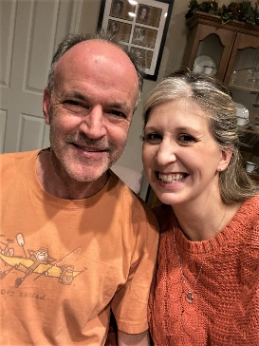
Welcome! We are Michael and Lisa O'Dowd. We call Henderson, NV, home but come from Colorado and Chicago. We love to go camping with the family enjoying wonderful places throughout the western United States. We have six children and having an RV has helped us feel relaxed, comfortable, and safe while experiencing the great outdoors. Our hope is that you will experience the same on your trip!

The purpose of this manual is to help you understand the basic operations of the motorhome. If you have any questions during your trip, please call us at 702-881-3821 or 702-373-3907.
Picking up the RV: Several days before your trip, we will reach out to confirm the pick-up date, time and location. Please allow at least one hour for a walk through of the RV, completion of an inspection checklist, completion of any paperwork and a question-and-answer time for you. After that, we hand you the keys and you are on your way!
If during your trip you want to extend your rental, you must call and verify availability, as another family may be waiting to start their adventure.


KEYS:

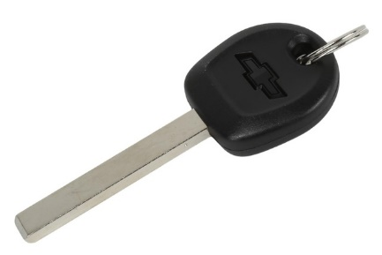

The long skinny key with GM logo is the ignition key.

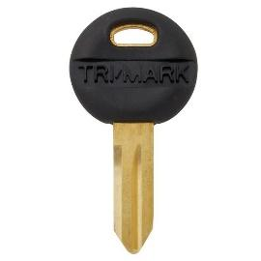
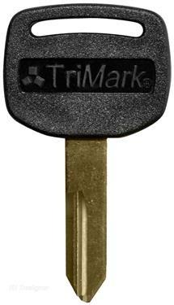
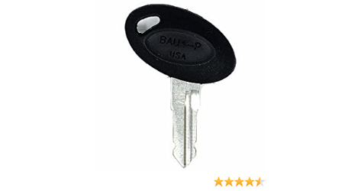
The fat gold key locks and unlocks the top lock on the camper door. This top lock is a deadbolt. The smaller round key locks and unlocks the bottom lock on the camper door. This locks the handle in place.

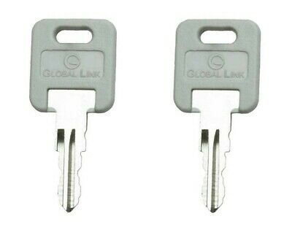

The silver key with round top is used to open all the compartments on the exterior of the RV.

You will receive one set of keys for the RV.
A lost set of keys will result in a $250 fee assessed against your security deposit.
RV Control Panel:
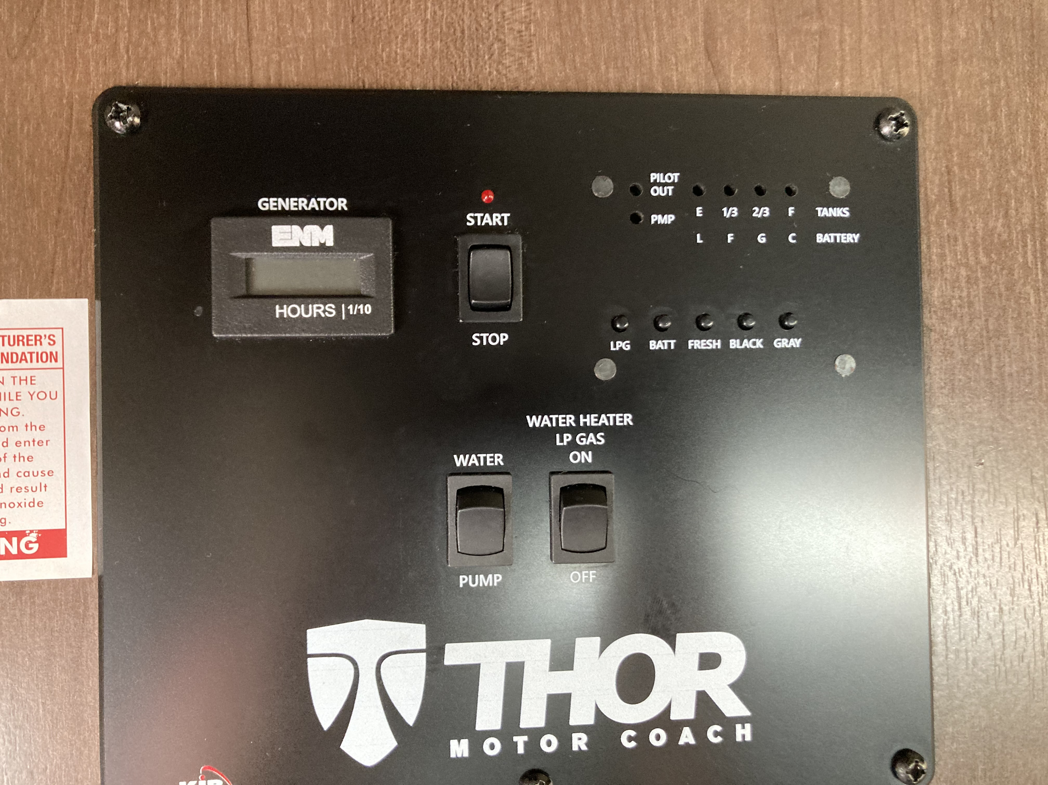

1
2

3

Generator:
#1 and #2 are for the generator. This is where you start the generator. You do not have to go outside to the generator compartment, simply start it from inside the RV. To start the generator, press the “Start” button and hold it down. If it is warm outside, it will start up quickly, if it is cold, it may take 10-15 seconds. If it does not start in 15 seconds, the unit will shut down. Let it rest for thirty (30) seconds and start over. The red light next to the word “Generator” will flash while trying to start and will be lit when the generator is running. The generator runs off the truck’s gas tank. If the gas tank gets to ¼ tank, the generator will not run leaving you ¼ tank to run the truck’s motor and drive to a gas station. Do not run the generator while you are sleeping.
#2 is the generator’s hour meter. If you start the generator at hour 51 and turn it off at hour 53, you used the generator for two (2) hours. Remember you get three (3) free hours of generator use each night you rent the RV. If you rent the RV for five nights, you will get 15 free hours of generator use. Anything over that will be charged $4.00 an hour. There is no refund for unused hours.

Holding Tanks:
The red box area labeled #3 is for the RV’s Holding Tanks. The four red lights at the top tell you how full or empty each tank is. 1 light = empty or very low. 2 lights = 1/3 tank, 3 lights = 2/3 tank, 4 lights = full. Each button underneath the lights is for each tank.
- LPS button is for Propane Tank 9.6 gallons
- Batt is for RV battery, not truck battery. These are separate.
- Fresh is for freshwater tank
- Black is for Black Tank – this is anything flushed down the toilet.
- Gray is for Gray Tank – this anything that goes down the drain of the sink or indoor shower.
Please remember to dump both the Black and Gray Tanks before returning the RV. Not emptying either or both tanks will result in a $50 fee being assessed against the Security Deposit.

Water Pump:
The Water Pump button is used to operate the “Water Pump.” The water pump is only used when not hooked up to a water source and you need water in a sink or the toilet. Push the button up to turn the water pump on. When done with the water, turn the water pump off. The red light labeled PMP tells you the water pump is on when lit.

Hot Water Heater:
The last box shows the Hot Water Heater. Use the button to turn the hot water heater on using propane. If the light marked “Pilot OUt” is lit, the pilot for the hot water heater is out. Turn the LP Gas Button OFF.

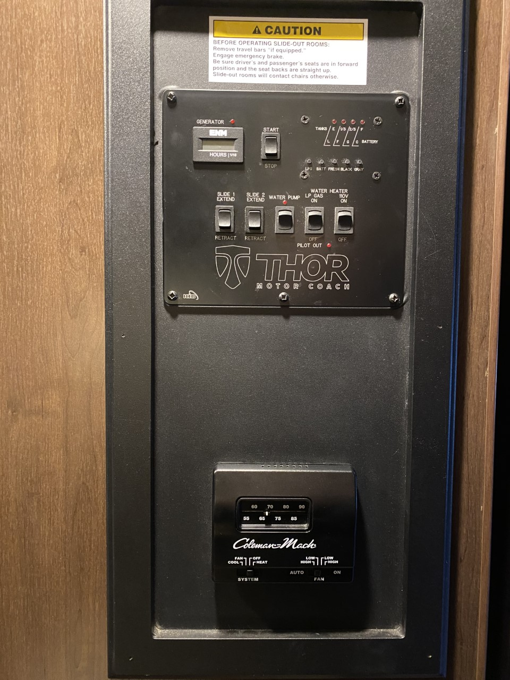
Thermostat for RV Heater and AC:
The thermostat is located in the master bedroom under the TV. Simply switch the bottom left switch to “Cool” and the bottom right switch to “Auto” to run the AC. Control the desired temperature with the sliding knob at the top. The AC is ducted throughout the coach on the ceiling and you can open/close each vent as desired. You can run the RV’s AC while driving by running the generator. After starting the generator, wait a minute or two before turning on the AC.
To run the RV’s heater, move the button at bottom left to “Heat” and select your desired temperature. The heat is vented throughout the coach near the floor. Be sure nothing is blocking the vent (blanket, suitcase, etc.) to ensure proper heating of the RV.
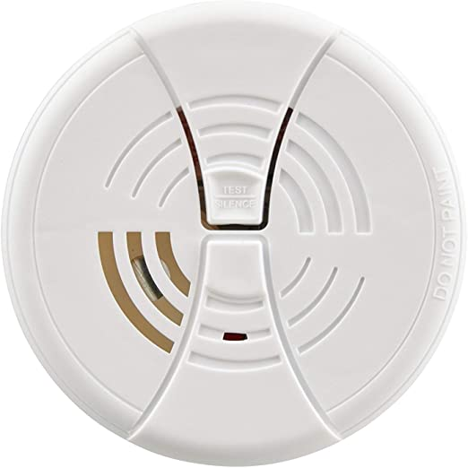
Smoke Detector:
The RV has a smoke detector on the ceiling above the sofa. It is located in the center of the RV and can easily be heard throughout the RV.

Carbon Monoxide and Propane Detector:
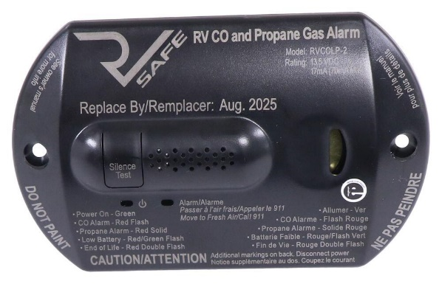
The RV has a Carbon Monoxide and Propane gas detector located next to the dinette when the slide is out. under the dinette table. Four (4) beeps and a flashing red light warn you of Carbon Monoxide. Continuous beep and solid red light alert you to propane. You can silence the alarm by pushing the “Silence/Test” button. If you hear this alarm, make sure the gas on the stove/oven is turned off and move outside to fresh air. If after letting the RV air out the alarm is still beeping, push the reset button. If the alarm continues to sound, call 911, move away from the RV, and get fresh air.
Kitchen Appliances:
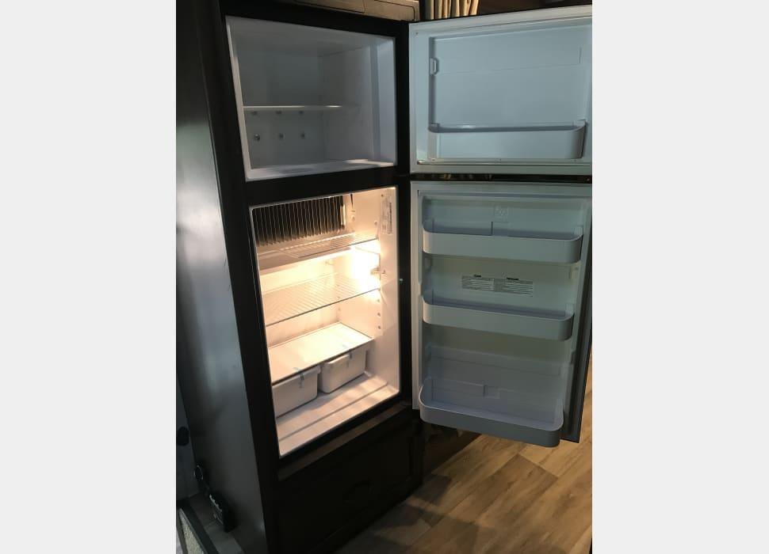
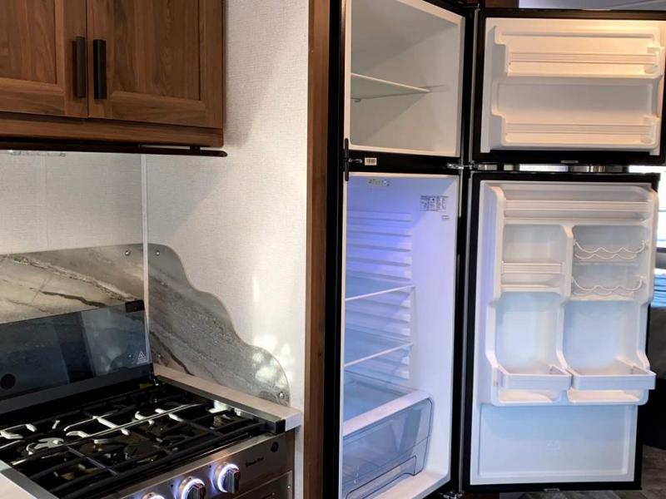
Refrigerator & Freezer: This RV comes with a 6 cubic foot refrigerator that runs off a solar panel mounted on the roof.
We will turn the refrigerator on 1 day prior to you picking up the RV so the refrigerator and freezer are cold when you pick it up.

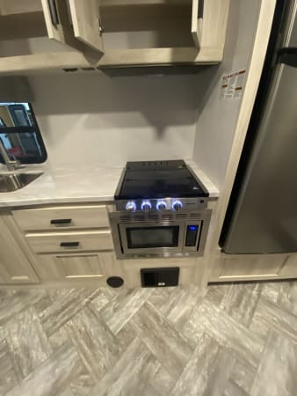
Stove / Cooking: A recessed three (3) burner range with a flush class cover is provided. The range runs off propane. A set of pots are located in the cupboards above the range. To light a burner, turn the knob for the desired burner to the flame icon (the first picture on each knob), and turn the ignitor knob on the far left. Adjust the flame using the burner knob to your desired setting.
There is a night light button on the far right. Push this button and a ring around each burner knob will glow blue.
Microwave / Convection Oven: A1.3 cubic foot convection microwave is provided. You can use the microwave while driving or not plugged into electricity at your camp site by running the generator. Once the generator starts, wait a minute or two before using the microwave. Using the microwave while plugged in to electricity at a campsite does not require the use of the generator.
Be sure to use microwave safe dishes and containers in the microwave.
Dishes: We provide plates, bowls, knives, forks, spoons, and cups in the cupboard above the sink.
Additional items for the kitchen you can rent:
*Coffee Maker *Toaster
*Waffle Maker *Electric Griddle
*Rice Cooker *Panini Press / Sandwich Maker

Kitchen Lights and Exhaust Fan: The switches for the kitchen lights are located under the cabinet right above the range. The exhaust fan is in the ceiling vent. Be sure to open the vent using the black turn knob.
Charging Station and USB Ports: There is a USB port in the dashboard and two (2) USB ports in the Master Bedroom to charge phones or power devices.
TV & Remote Controls:
This unit contains:
*DVD/CD player
*Digital FM Tuner
*Bluetooth wireless technology
*Input (USB and 3.5 mm aux)
*Remote controls

To turn the unit on, press the power button located to the left of the DVD input.

To select desired mode, press the button on the far left of the display screen. To select the audio distribution, push “A,” “B,” or “C” until sound is playing where you want it. Use the arrow keys on the far right of the display screen to change the radio station. Use + and – buttons to raise and lower the volume.

To pair Bluetooth, press the mode button (see above for picture) until BT appears on display screen and blinks. Now it is in pairing mode. Activate the external BT device and enter BT searching mode. Start pairing following the directions on external device. When the external BT device searched the unit, WMSDVDZ3 will appear on the display of the external BT device. Select it and make connection.

TV and DVD/CD Player:

The cab over bed has a large TV on a swing mount so the TV can be visible by people on the cab over bed or turned for people in the main living area. Insert the DVD into the DVD/CD unit located in the cabinet above the dinette. Press mode button the select until DVD appears. There is a remote control for the TV.

Getting to your Campsite with Hookups:

Male-end
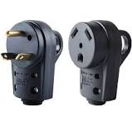
Connecting the RV to the Camp Site Electricity:

The RV comes with a 30 ft. heavy duty yellow electrical cord to connect the RV to the power source provided at the campsite. The RV requires a 30-amp outlet. Plug the female-end into the motorhome’s electrical outlet and then turn the head of the female-end to the right to lock in place. The power compartment is located on the driver’s side. The other end (male) needs to be plugged into the outlet provided at the campsite.

Be sure all the circuit breakers in the campsite Utility Box are turned on.

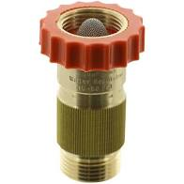
Connecting the RV to the Camp Site Water Supply:
Look for a white-water hose stored in a bin in the biggest storage compartment toward the rear of the RV (Driver’s side). Connect the male end of the garden hose to the “Fresh Water Connection” on the RV. Connect the female end to the water supply at the campsite. Make sure a “Water Pressure Regulator” is connected between the camp site’s water supply and the white hose. If not, the water pressure may cause damage within the RV water system. Finally, turn on the water from the campsite faucet.
Water pressure regulator

Connecting the Sewer Hose from the RV to the Campsite Sewer Supply: Look for a sewer hose stored in a bin near the sewar valves. Remove the cover from the sewer pipe on the RV.
- Connect the sewer hose to the sewer pipe.
- Extend the hose long enough to reach the sewer outlet at the campsite.
- Install the clear elbow into the sewer outlet at the campsite and connect the other end of the sewer house to the elbow.
- Pull the third valve located on the passenger side indicated by a square black piece of Velcro. (this is the aux tank that holds everything first)
- Pull the BLACK valve. This is everything you flushed down the toilet. Wait until you do not hear anything rushing out.
- Pull the GREY valve. This is everything that went down the sink drains and shower drain. This water will wash out the sewar hose.
- Close both the BLACK and GREY valves.
- Hook a hose up to the “Sani-Flush” connection to the left of the “Fresh Water Connection.” Make sure a “Pressure Regulator” is between the hose and the connection.
- Turn on the water for 3-4 minutes. This rinses the BLACK and GREY tanks.
- Pull the BLACK and GREY valves again to drain both tanks.
- When done:
  - Close all three valves
  - Put the sewer hose away
  - Put the water hose away.

It is best to leave the black and gray holding tanks closed until you are ready to “Dump.” If you leave the valves open, you may get a sewer smell in the RV.


Add-On Items


Thank you for renting an RV with us. To enhance your trip, we offer the following add on items to help you and your family enjoy your Adventure even more! All of our add on items are subject to availability on a first-come, first-served basis.

Please email for availability at:
info@adventureiscalling.us

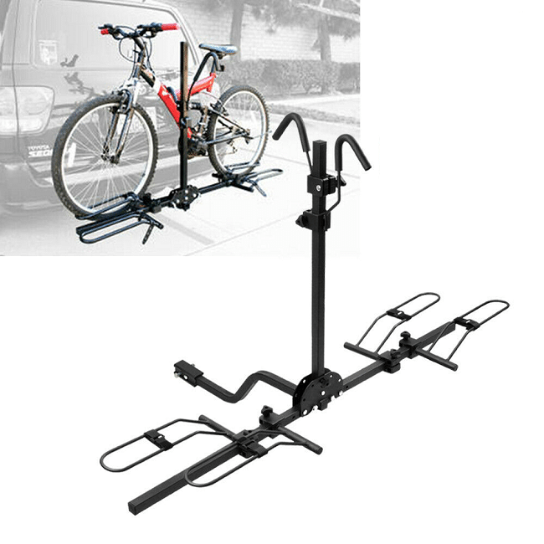
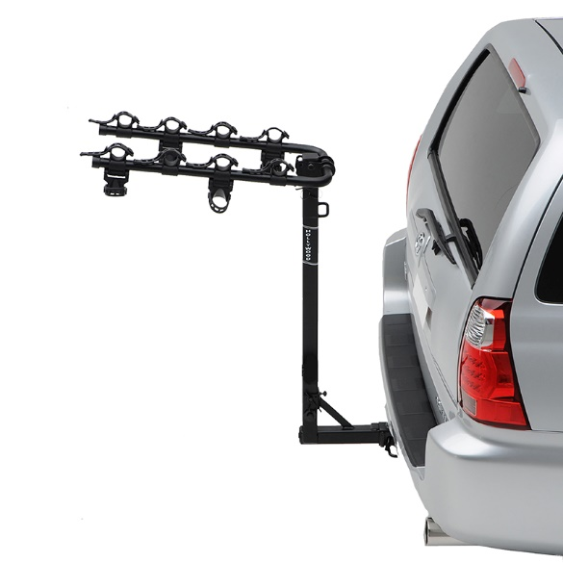
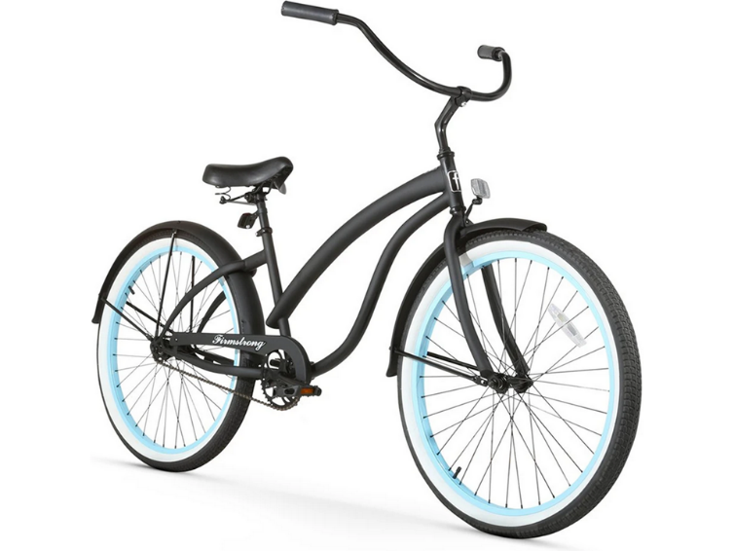
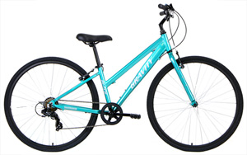
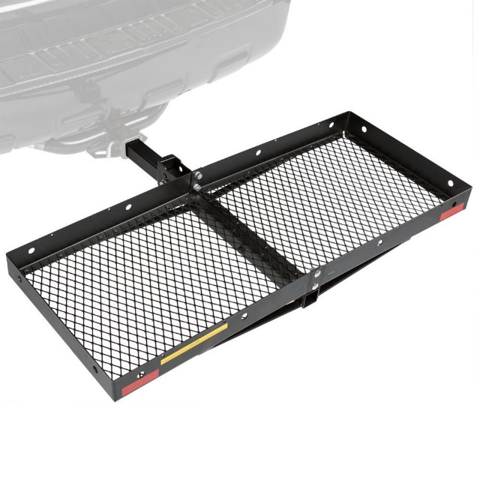
Bikes and Bike Racks
For the active explorers, we offer Beach Cruisers and Mountain Bikes. We have bikes for men, women and teen. We also offer a way to bring those bikes along. Two different styles of bike racks. Listed below are the costs for each item.
Bikes: $5 each per day
Bike Rack: $10 (flat rate)

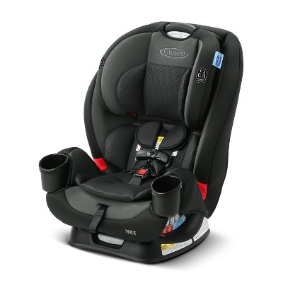
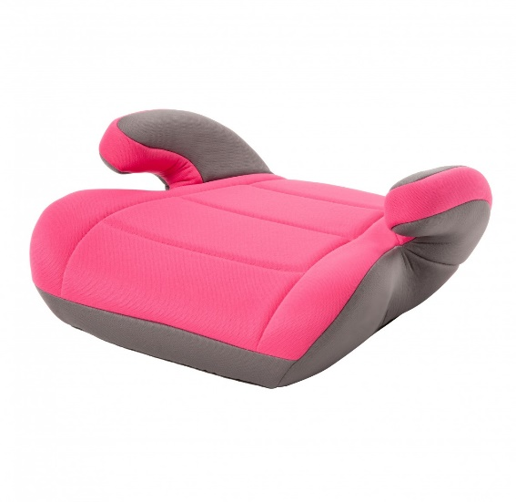
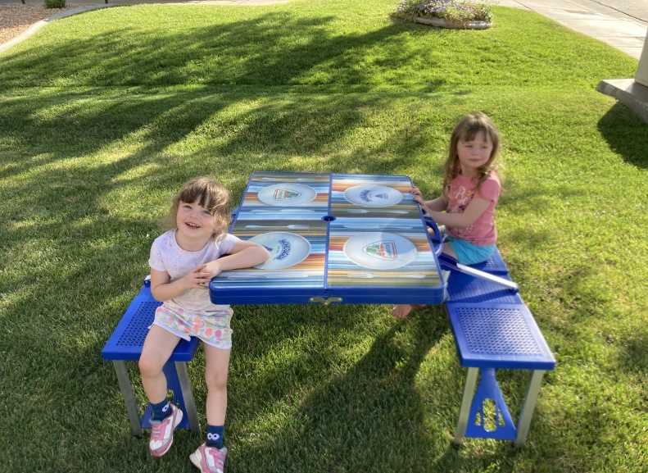
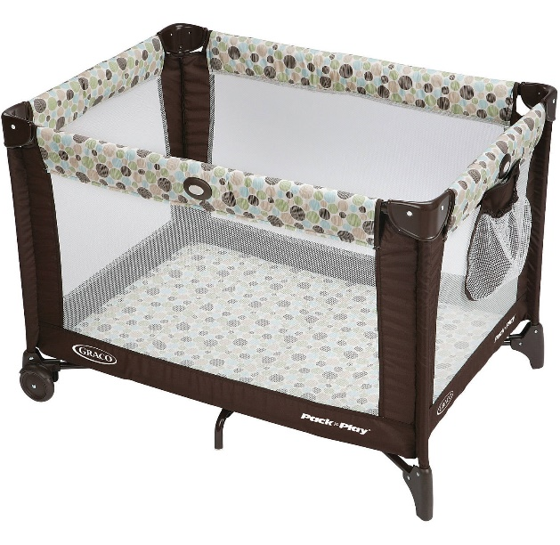
Small Children Items
Travelling with littles? We have them taken care of too! No need to lug heavy car seats through the airport, and no need to worry where baby is going to sleep in the RV’s. We even can add a touch of fun to eating outside, not to mention extra room for adults with our child size picnic table!
Picnic table: $5 flat rate
Pack N Play: $10 flat rate
Car Seat: $10 flat rate
Booster Seat: $5 flat rate

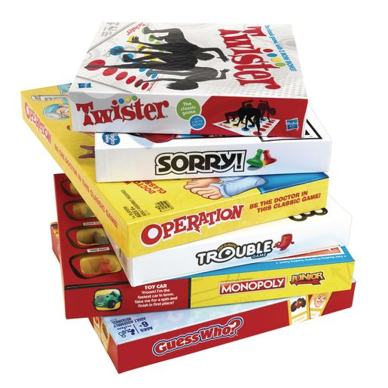
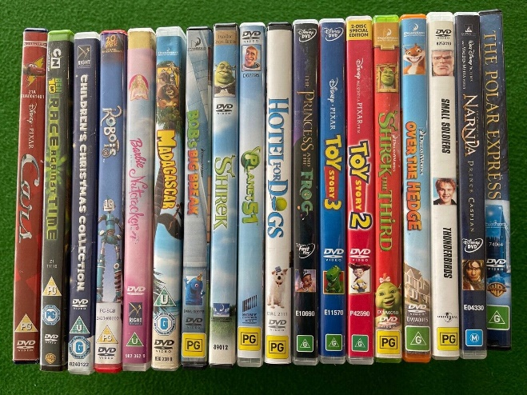
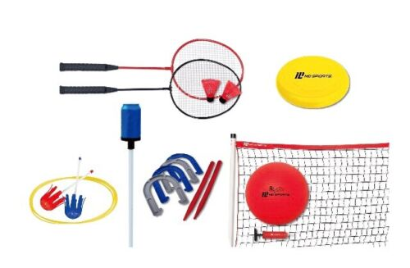
Games and Movies
Bad weather? No worries, we offer a wide variety of family friendly movies, and board games. Good weather? Get outside and play with our array of outdoor game sets like croquet, badminton, footballs (and others), bocce ball and many more!
Croquet set: $10 flat rate
Two Movies: $5 flat rate
Two Board Games: $5 flat rate
Outdoor playsets: $7 flat rate

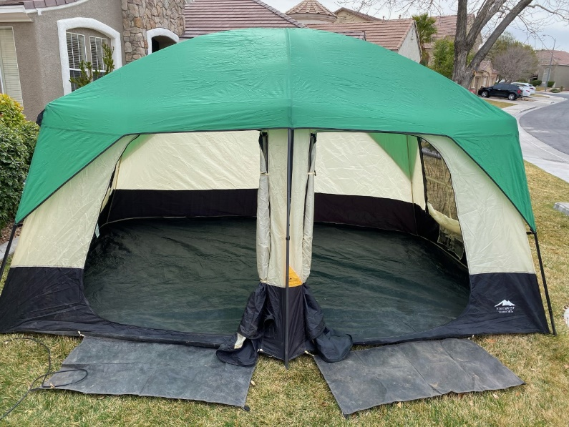
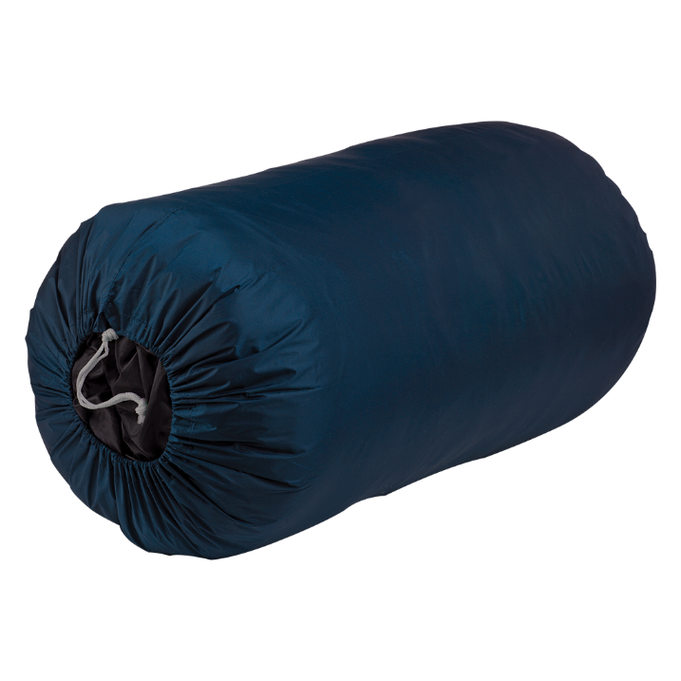
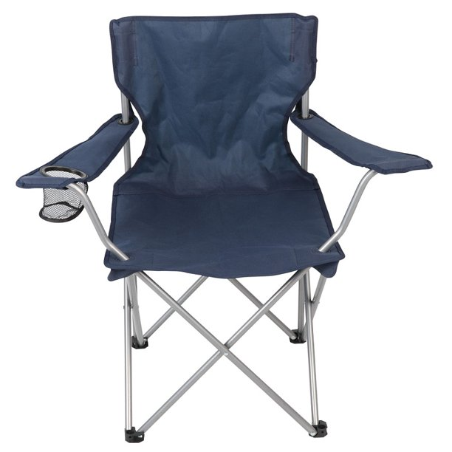
Camping Add-Ons
Need extra space or have guests? Why not rent our two-room 8 person tent, and allow your friends or kids to get the true camping experience. Along with our big tent, we do have a smaller 4 person tent. We also have sleeping bags and extra camping chairs for even more space and seating.
One additional Camping Chair: $5 (each) flat rate
(4 chairs come with rental)
Sleeping bag: $5 flat rate
4 person Tent: $10 flat rate
8 person tent: $15 flat rate

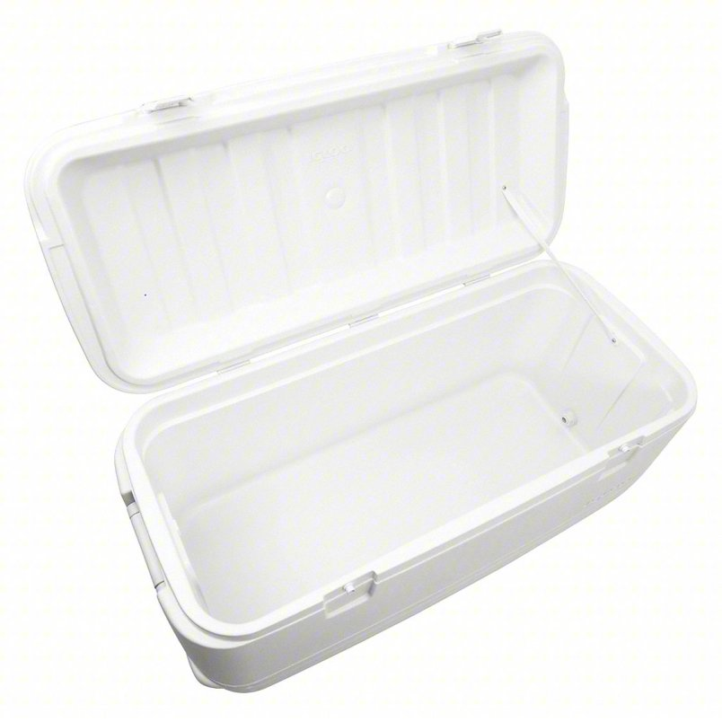
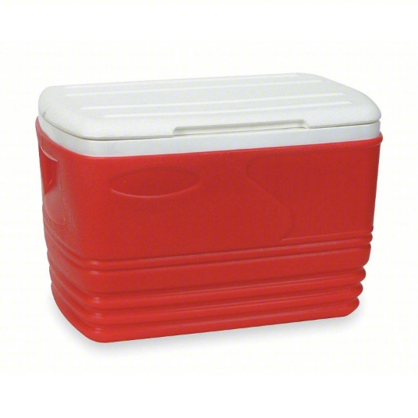
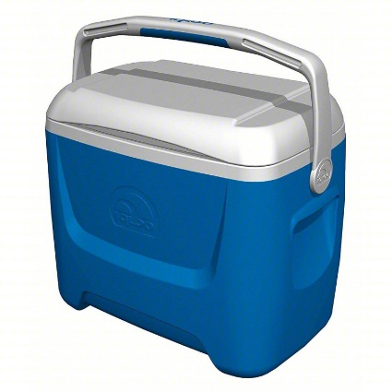
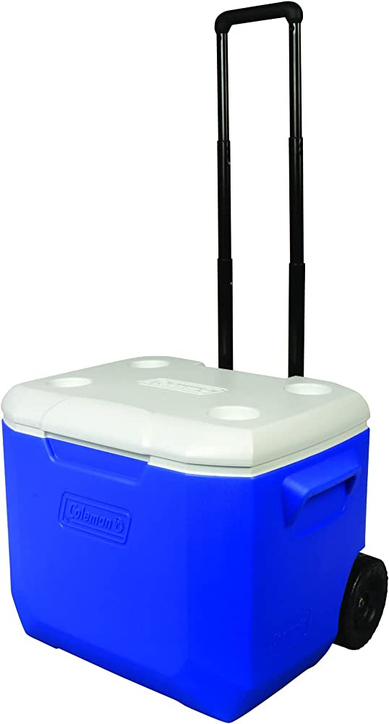
Cooler Add-Ons
RV refrigerators don’t always have adequate space for all your cooking needs. Why not add on a cooler to help bring along all your favorite meals and snacks. We have several sizes available.
Large (36in x 14in x 15in): $20
Medium (27in x 14in x 14in): $15
Wheeled Small (16in x 10in x 15in): $10
Small (16in x 10in x 15in): $10

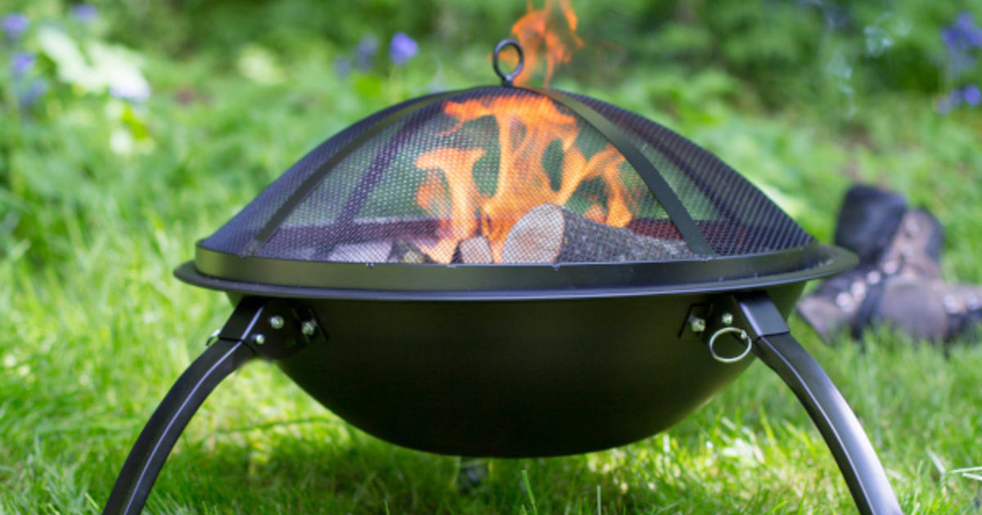
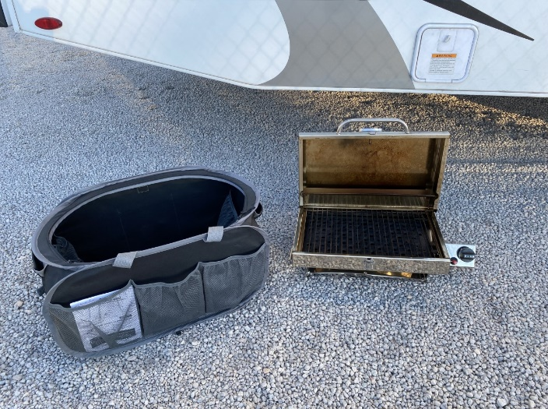
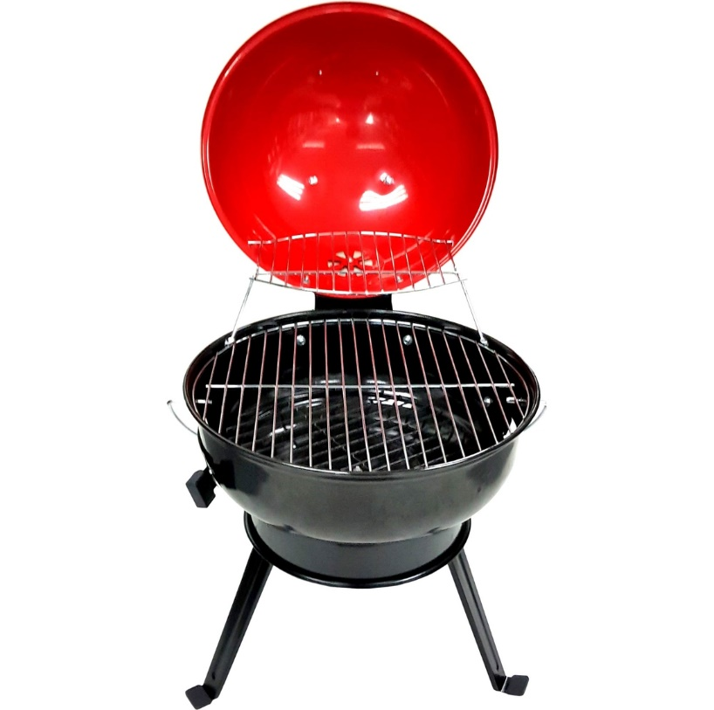
Grilling Add-Ons
What’s camping without camp fires and outdoor cooking. With these add on packages, you can do both! Our grill package includes: grill, a bucket of matchlight charcoal, lighter fluid and grill utensils. The fire pit package includes: Fire pit, 10 pieces of firewood, and a small axe. These items must be returned clean or there will be $20 fee for cleaning.
Fire Pit package: $25 flat rate
Grill Package: $25 flat rate
Propane Grill: $25 flat rate (small propane tank not included)

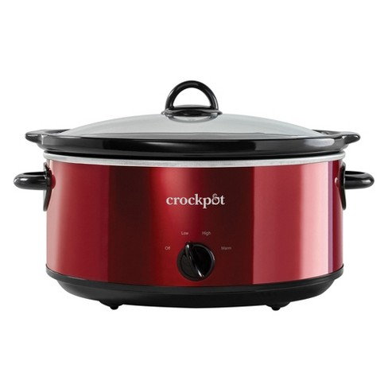
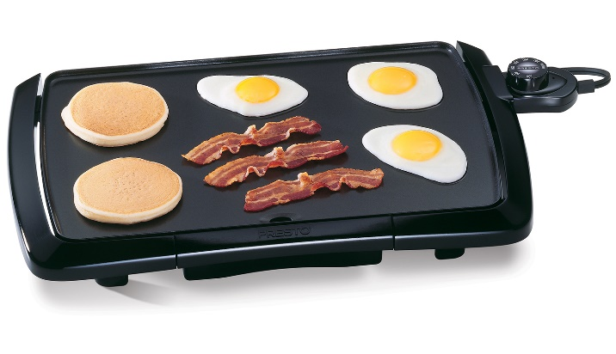
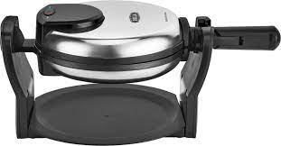
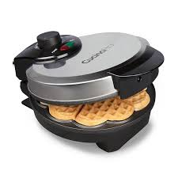
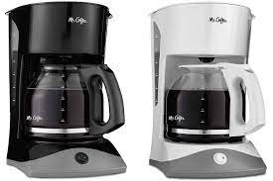
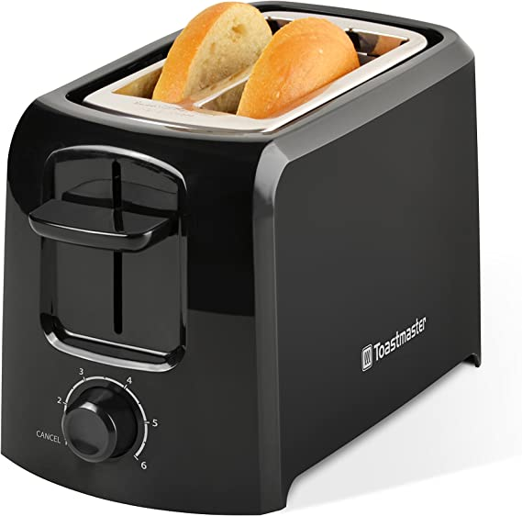
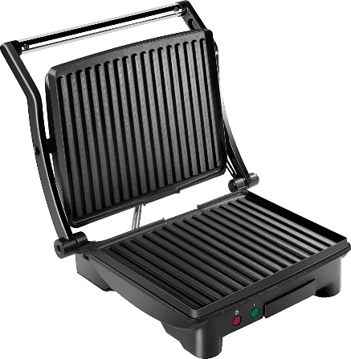
Cooking Add-Ons
MMM, bacon! Everyone loves the smell of bacon in the morning. These add on items allow you to have all your favorite breakfast food items including coffee! There is nothing better then prepping dinner and leaving to hike for the day and coming home to a fully cooked meal in the crock pot!
Toaster: $5.00 flat rate
Coffee Pot: $5.00 flat rate
Electric Griddle: $5.00 flat rate
Crock Pot: $5.00 flat rate
Panini Maker: $5.00 flat rate
Waffle Maker: $5.00 flat rate

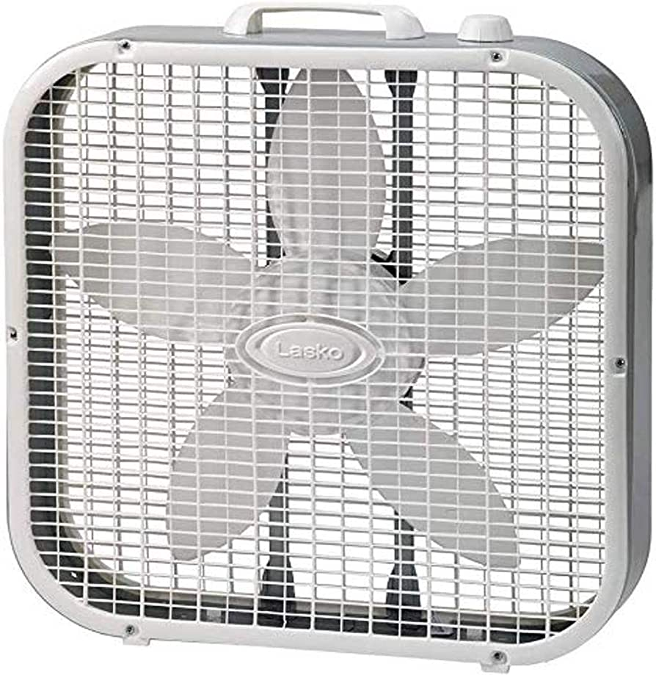
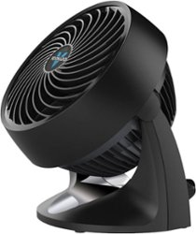
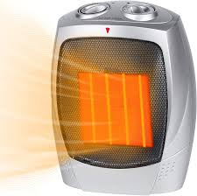
Heat/AC Add-Ons
When it comes to extreme weather, summer or winter. It is always nice to have a little extra help cooling down your unit or heating it up. These little add-ons, add so much to your trip! Making the inside of the RV just as enjoyable as the outside!
Large Box Fan: $5.00 flat rate
Small Fan: $5.00 flat rate
Space Heater: $5.00 flat rate
Small Box Heater: $5.00 flat rate

