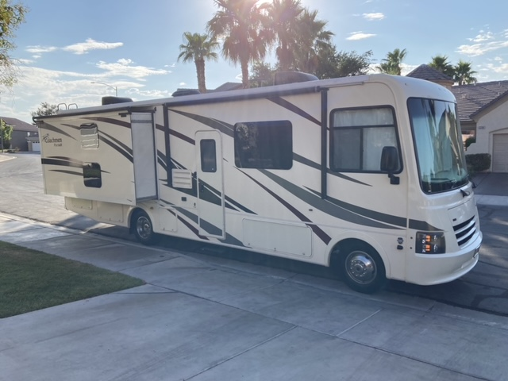

Welcome to

“Coco”

Operator’s Manual

2023



Adventure Is Calling RV Rental

[www.Adventureiscalling.us](http://www.Adventureiscalling.us)

295 E. Eldorado Lane

Las Vegas, NV 89123

Mike 702-881-3821

Lisa 702-373-3907

Table of Contents

Item Description _ Page #

Welcome ……………………………………………………………………………………………………. 3

Picking up the RV ………………………………………………………………………………………… 3

Keys ……………………………………………………………………………………………………………. 4

RV Control Panel ………………………………………………………………………………………… 5

Generator ………………………………………………………………………………………… 5

Holding Tanks …………………………………………………………………………………… 5

Slide Outs …………………………………………………………………………………………. 6

Water Pump ……………………………………………………………………………………… 6

Hot Water Heater ……………………………………………………………………………… 6

Thermostat for Heater and AC ……………………………………………………………………. 7

Smoke Detector and Carbon Monoxide/Propane Detector …………………………. 7

Kitchen Appliances ……………………………………………………………………………………… 8

Refrigerator ………………………………………………………………………………………. 8

Microwave ………………………………………………………………………………………… 8

Stove and Oven ………………………………………………………………………………… 8

Kitchen lights and Exhaust Fan …………………………………………………………. 9

Pop-up Power Bar and USB Ports ……………………………………………………… 9

TVs, DVD Players and Remotes …………………………………………………………………… 9

Exterior Compartments ………………………………………………………………………………. 10

**Getting to your Campsite with Hookups**:

Hooking up to RV Camp Electricity …………………………………………………… 11

Hooking up to RV Camp Water ………………………………………………………… 11

Hooking up to RV Camp Sewer ………………………………………………………… 12

**Leaving Your RV Campsite**:

Disconnect from RV Camp Water

Dump Black and Gray Holding Tanks

Flush Black Tank

Disconnecting from RV Camp Electricity

**Returning the RV**:

Filling up the Gas Tank

Filling up the Propane Tank

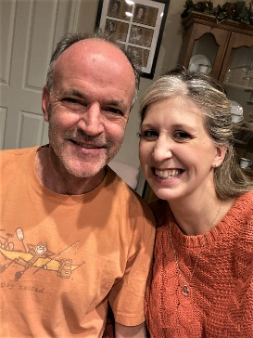Welcome! We are Michael and Lisa O'Dowd. We call Henderson, NV, home but come from Colorado and Chicago. We love to go camping with the family enjoying wonderful places throughout the western United States. We have six children and having an RV has helped us feel relaxed, comfortable, and safe while experiencing the great outdoors. Our hope is that you will experience the same on your trip!

The purpose of this manual is to help you understand the basic operations of the motorhome. If you have any questions during your trip, please call us at 702-881-3821 or 702-373-3907.

**Picking up the RV**: Several days before your trip, we will reach out to confirm the pick-up date, time and location through your platform email system. Please allow at least one hour for a walk through of the RV, completion of an inspection checklist, completion of any paperwork and a question-and-answer time for you. After that, we hand you the keys and you are on your way!

If during your trip you want to extend your rental, you must call and verify availability, as another family may be waiting to start their adventure.

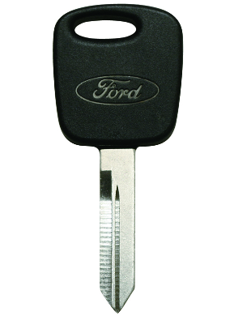**KEYS**:

The long skinny key is the ignition key.

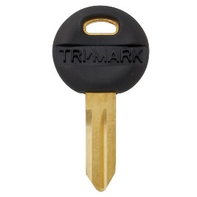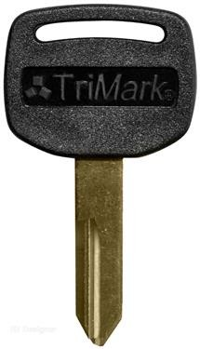

The fat gold key locks and unlocks the top lock on the camper door. This top lock is a dead bolt. The smaller round key locks and unlocks the bottom lock on the camper door. This locks the handle in place.

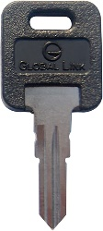The key with a square, black colored top is used to open the front engine compartment on the exterior of the RV. When the key hole is up and down, the compartment door is unlocked. When the key hole is side to side, the compartment door is locked.

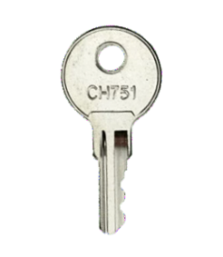

The final key is a silver key. This key unlocks all the exterior compartments.

***A lost set of keys will result in a $200 fee assessed against your security deposit.***

**RV Control Panel**:

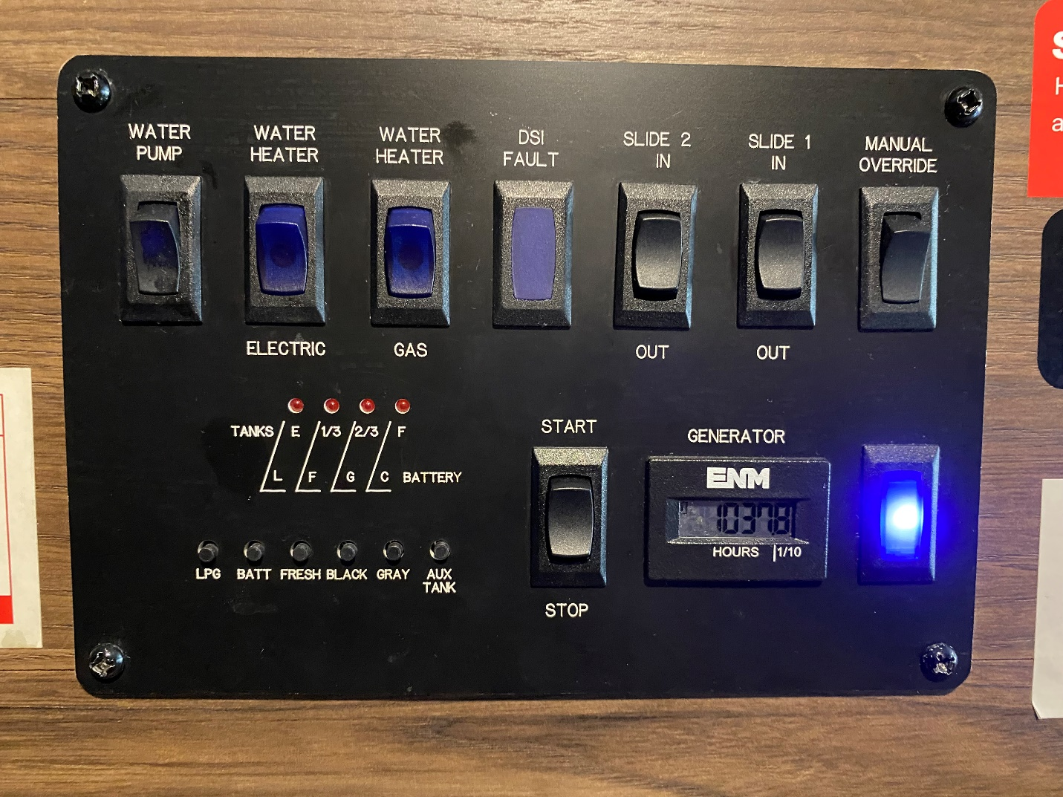

5

3

4

6

1 2

**Generator**:

#1 and #2 are for the generator. This is where you start the generator. You do not have to go outside to the generator compartment, simply start it from inside the RV. To start the generator, press the “Start” button and hold it down. If it is warm outside, it will start up quickly, if it cold outside, it may take 10-15 seconds. If it does not start in 15 seconds, the unit will shut down. Let it rest for thirty (30) seconds and start over. The red light next to the word “Generator” will flash while trying to start and will be lit when the generator is running. The generator runs off the truck’s gas tank. If the gas tank gets to ¼ tank, the generator will not run, leaving you ¼ tank to run the truck’s motor and drive to a gas station***. Do not run the generator while you are sleeping.***

#2 is the generator’s hour meter. If you start the generator at hour 51 and turn it off at hour 53, you used the generator for two (2) hours. Remember you get three (3) free hours of generator use each night you rent the RV. If you rent the RV for five nights, you will get 15 free hours of generator use. Anything over that will be charged $4.00 an hour. There is no refund for unused hours.

**Holding Tanks:**

The red box area labeled #3 is for the RV’s Holding Tanks. The four red lights at the top tell you how full or empty each tank is. 1 light indicates tank is empty or very low. 2 lights are 1/3 tank, 3 lights is 2/3 tank, 4 lights is full. Each button underneath the lights is for each tank.

* LPS button is for Propane Tank 9.6 gallons
* Batt is for RV battery, not truck battery.
* Fresh is for fresh water tank
* Black is for Black Tank – this is anything flushed down the toilet.
* Gray is for Gray Tank – this is anything that goes down the drain of the sink or indoor shower.

Please remember to dump both the Black and Gray Tanks before returning the RV. ***Not emptying either or both tanks will result in a $50 fee being assessed against the Security Deposit.***

**Slide Outs**:

Box #4 shows the two slide-out buttons. The button on the left moves the kitchen and sofa slide while the button on the right moves the bunk and master bedroom slide. Pushing the button toward “Extend” moves the slide out while pushing the button toward “Retract” moves the slide back in. The slide will stop when fully out or fully back in. To operate the slides, the truck must be in park and the engine turned off.

**Water Pump**:

#5 shows the button to operate the “Water Pump.” The water pump is only used when not hooked up to a water source and you need water in a sink or the toilet. Push the button up to turn the water pump on. When done with the water, turn the water pump off. The red light above this switch tells you the water pump is on when lit.

**Hot Water Heater**:

Box #6 above shows the two buttons to operate the “Hot Water Heater.” When the RV is plugged into electricity, use the button on the right to turn the hot water heater on using electricity. When the RV is not plugged into electricity and you need to turn the hot water heater on, use the button on the left to use propane to heat the water***. If the light below this switch is on, turn the LP Gas Button OFF as the pilot light is not lit.***

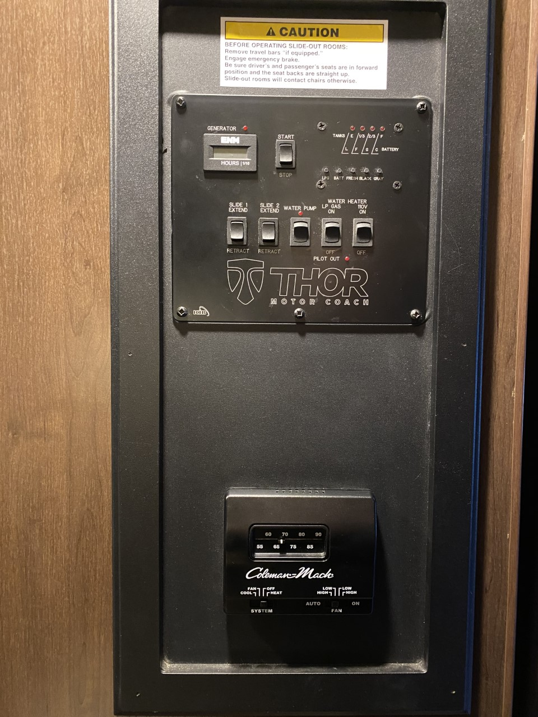**Thermostat for RV Heater and AC**:

The thermostat is located in the hallway right under the RV Control Panel. Simply switch the bottom left switch to “Cool” and the bottom right switch to “Auto” to run the AC. Control the desired temperature with the sliding knob at the top. The AC is ducted throughout the coach on the ceiling and you can open/close each vent as desired. You can run the RV’s AC while driving by running the generator. After starting the generator, wait a minute or two before turning on the AC.

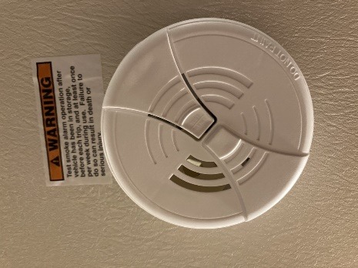To run the RV’s heater, move the button at bottom left to “Heat” and select your desired temperature. The heat is vented throughout the coach near the floor. Be sure nothing is blocking the vent (blanket, suitcase, etc.) to ensure proper heating of the RV.

**Smoke Detector**:

The RV has a smoke detector on the ceiling above the dinette. It is located in the center of the RV and can easily be heard throughout the RV.

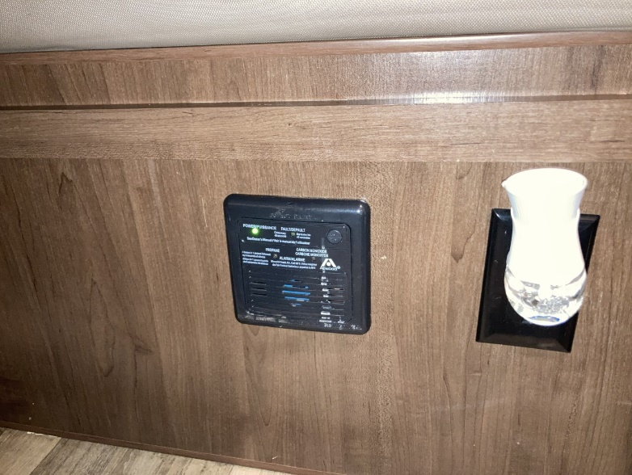

**Carbon Monoxide and Propane Detector**:

The RV has a Carbon Monoxide and Propane gas detector located under the dinette table. Four (4) beeps sound in one second and then there is five (5) seconds of silence, and then four (4) beeps sound, etc. If you hear this sound, make sure the gas on the stove/oven is turned off and move outside to fresh air. If after letting the RV air out the alarm is still beeping, push the reset button. If the alarm continues to sound, call 911, move away from the RV, and get fresh air.

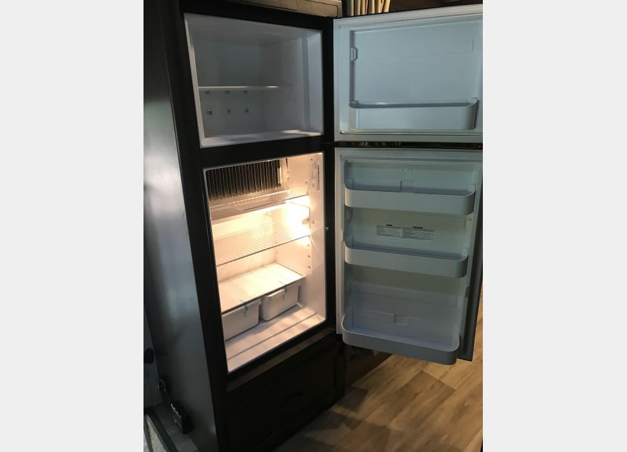**Kitchen Appliances**:

**Refrigerator & Freezer**: This RV comes with a mid-size refrigerator/freezer. The refrigerator is 6 cubic feet and the freezer is 2 cubic feet. The refrigerator can run off electricity or propane. If you leave the controls on “Auto,” the refrigerator will switch over from one to the other when you are plugged into electricity or not.

We will turn the refrigerator on 1 day prior to you picking up the RV so the refrigerator and freezer are cold when you pick it up.

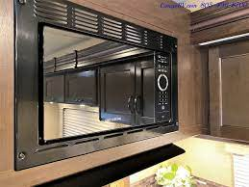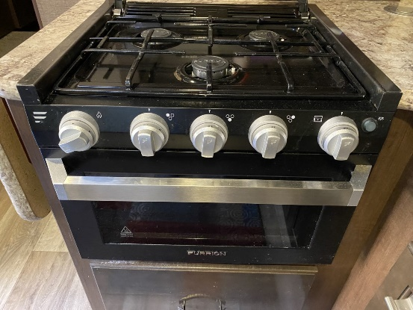**Stove and Oven**: A three burner gas stove is provided. A set of pots are located in the drawer below the oven. To light a burner, turn the knob for the desired burner to the flame icon (the first picture on each knob), and turn the ignitor knob on the far left. Adjust the flame using the burner knob to your desired setting. To light the oven, open the oven door and peer inside below the shelf. Push the oven knob in (knob on far right) and turn to the flame icon. Turn the ignitor knob and watch for the pilot light to stay lit. A cookie sheet is provided inside the oven. ***Be sure to remove the cookie sheet before lighting the oven.*** Once the pilot light stays lit, turn the oven knob to the desired temperature. When done with a burner, or the oven, be sure to turn each knob completely off. There is a night light button on the far right. Push this button and a ring around each burner knob will glow blue.

**Microwave**: A microwave oven is also provided for you. You can use the microwave while driving or not plugged into electricity at your camp site by running the generator. Once the generator starts, wait a minute or two before using the microwave. Using the microwave while plugged in to electricity at a campsite does not require the use of the generator. ***Be sure to use microwave safe dishes and containers in the microwave. Do not use the blue metal plates, bowls or mugs in the microwave.***

**Kitchen Lights and Exhaust Fan**: The switches for the kitchen lights and exhaust fan are located under the cabinet right above the sink. The exhaust fan is in the ceiling vent. Be sure to remove the sunblock cushion before running the exhaust fan and be sure to open the vent using the black turn knob.

**Power and USB Ports**: On the front panel of the kitchen counter there is a power outlet as well as a light switch. USB ports are also available in the dashboard, near the cab over bed and in the master bedroom.

**TV’s, DVD’s and Remote Controls**:

There are a total of 2 TV’s and DVD players in the RV.

1. The Kitchen has a large TV on a mount in the wall and so the TV can be visible by people on the cab over bed at the dinette, or on the couch. The DVD/Blue Ray Disk player for this TV is located in the over the door. There is a large remote for the TV and a smaller remote for the DVD/Blue Ray Disk Player.
2. The master bedroom TV also has a DVD player behind it. The TV remote and the DVD player remote are located behind the TV as well.

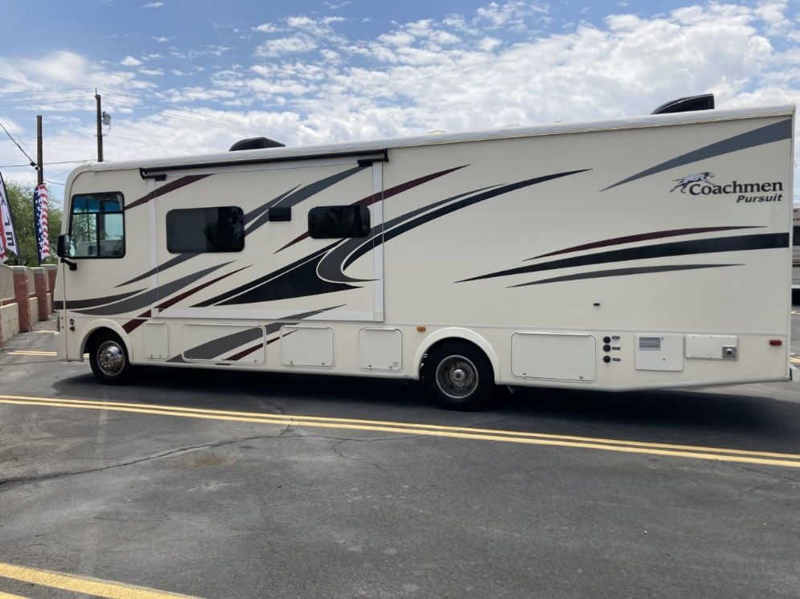**Exterior Compartments**:

**Driver Side**

1

2

3 4 5

1. This small carpeted compartment is left empty for your personal use/storage.

2. This is the propane compartment

3. This compartment houses the generator.

4. This is your power box

5. This compartment is for all your sewer needs

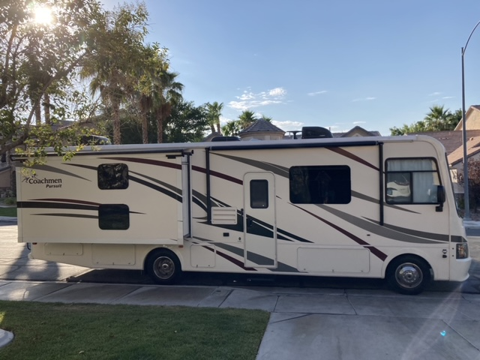**Passenger Side**

1

1. 3 4
2. This compartment is empty for storage.
3. This compartment is empty for storage.
4. This compartment is empty for storage.
5. Camping chairs and small ladder

**Getting to your Campsite with Hookups**:

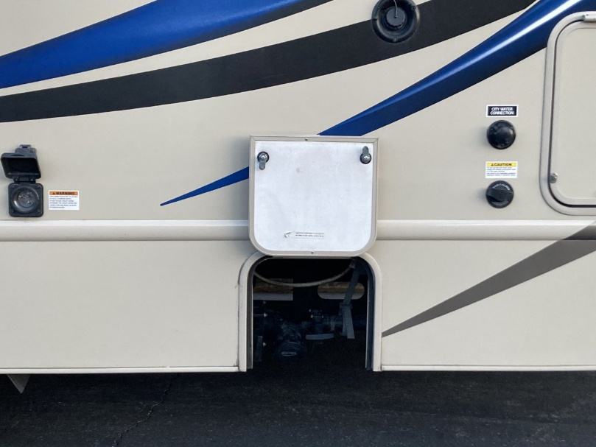 Fresh Water

connection

RV’s Electrical

Outlet Black Water Tank

Flush Hookup

Black and Gray

Tank Drains

*All the hook-ups listed above are located on the Driver’s side toward the rear of the RV*

Male-end Female-end

**Connecting the RV to the Camp Site Electricity**:

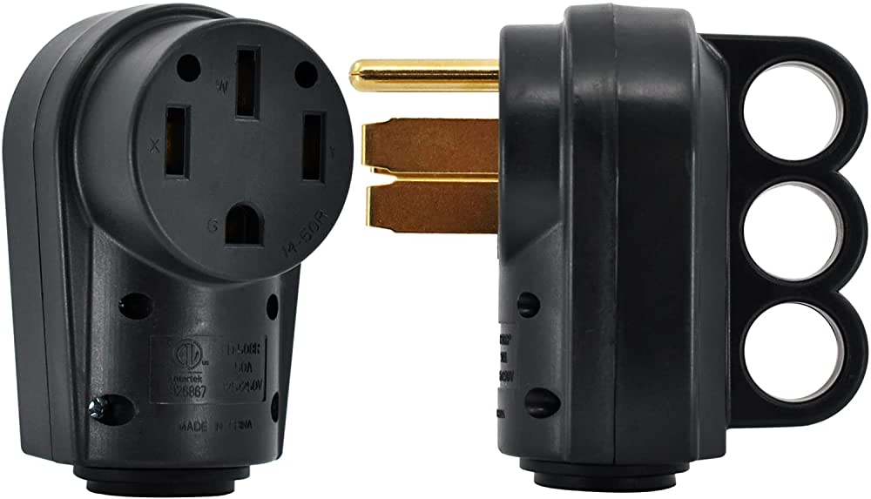

The RV comes with a 30 ft. heavy duty electrical cord to connect the RV to the power source provided at the campsite. The RV requires a 50-amp outlet. Plug the female-end into the motorhome’s electrical outlet and then turn the head of the female-end to the right to lock in place. Finally, plug the male-end into the outlet provided at the campsite.

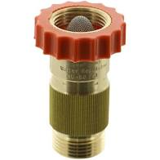**Connecting the RV to the Camp Site Water Supply**:

Look for a white-water hose and blue water filter stored in a gray bin in the biggest storage compartment toward the rear of the RV (Driver’s side). Connect the male end of the garden hose to the “Fresh Water Connection” on the RV. Connect the female end to the water supply at the campsite. Make sure a “Water Pressure Regulator” is connected between the camp site’s water supply and the white hose. If not, the water pressure may cause damage within the RV water system. Finally, turn on the water from the campsite faucet.

Water pressure regulator

**Connecting the Sewer Hose from the RV to the Campsite Sewer Supply**: Look for a sewer hose stored in a bin in the sewer storage compartment toward the rear of the RV (driver’s side). Remove the cover from the sewer pipe on the RV.

* Connect the sewar hose to the sewer pipe.
* Extend the hose long enough to reach the sewer outlet at the campsite.
* Install the clear elbow into the sewer outlet at the campsite and connect the other end of the sewer house to the elbow.
* Pull the BLACK valve. This is everything you flushed down the toilet. Wait until you do not hear anything rushing out.
* Pull the GREY valve. This is everything that went down the sink drains and shower drain. This water will wash out the sewar hose.
* Close both the BLACK and GREY valves.
* Hook a hose up to the “Sani-Flush” connection to the left of the “Fresh Water Connection.” Make sure a “Pressure Regulator” is between the hose and the connection.
* Turn on the water for 3-4 minutes. This rinses the BLACK and GREY tanks.
* Pull the BLACK and GREY valves again to drain both tanks.
* When done:
  + Close both valves
  + Put the sewar hose away
  + Put the water hose away.

*It is best to leave the black and gray holding tanks closed until you are ready to “Dump.” If you leave the valves open, you may get a sewer smell in the RV.*



**Add-On Items**

Thank you for renting an RV with us. To enhance your trip, we offer the following add on items to help you and your family enjoy your Adventure even more! All of our add on items are subject to availability on a first-come, first-served basis.

Please email for availability at:

info@adventureiscalling.us

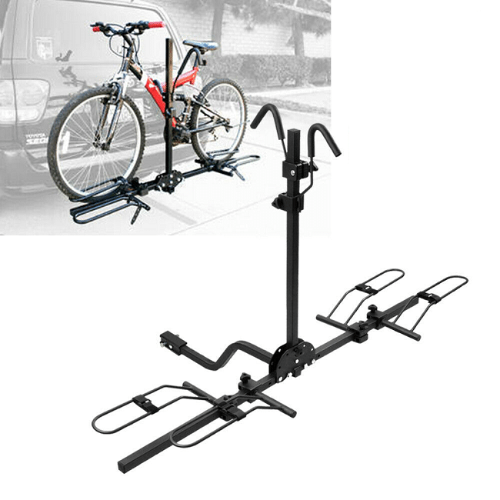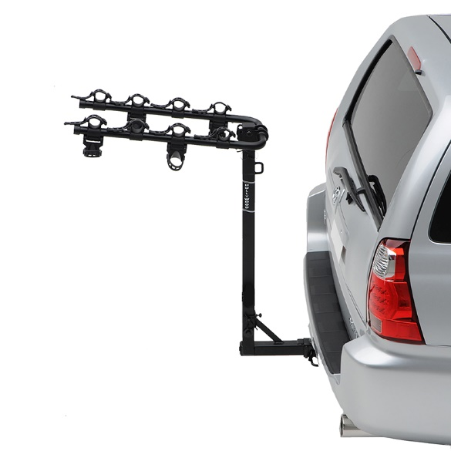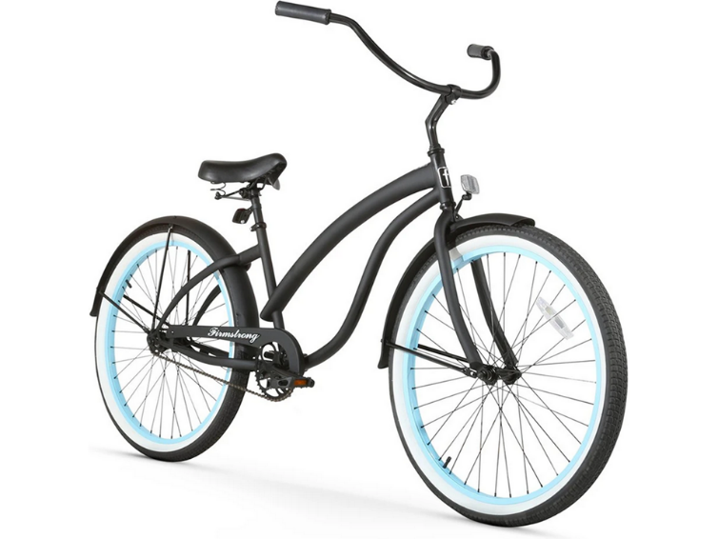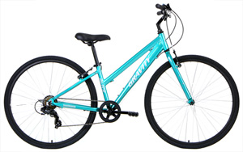

**Bikes and Bike Racks**

For the active explorers, we offer Beach Cruisers and Mountain Bikes. We have bikes for men, women and teen. We also offer a way to bring those bikes along. Two different styles of bike racks. Listed below are the costs for each item.

**Bikes: $5 each per day**

**Bike Rack: $10 (flat rate)**

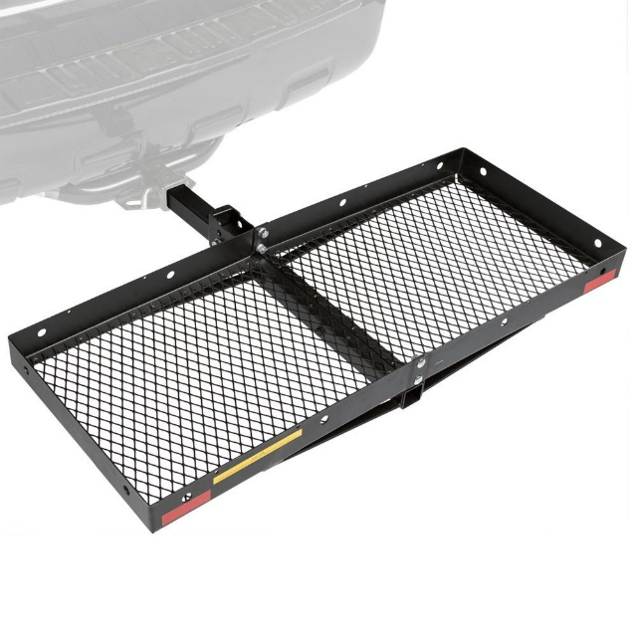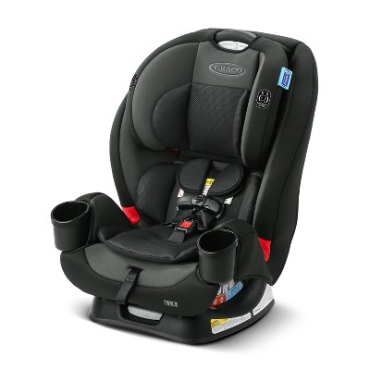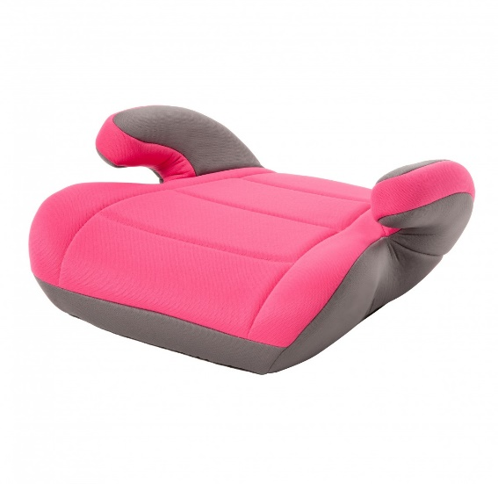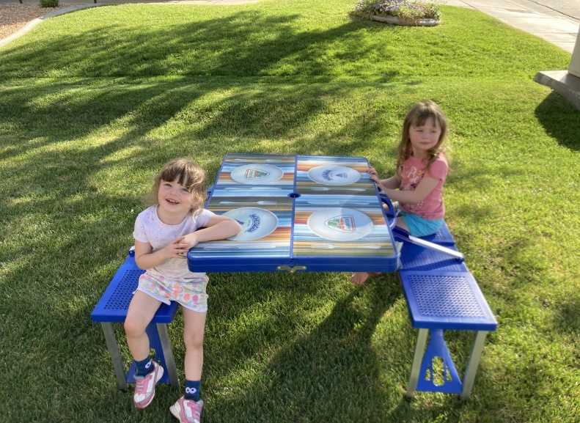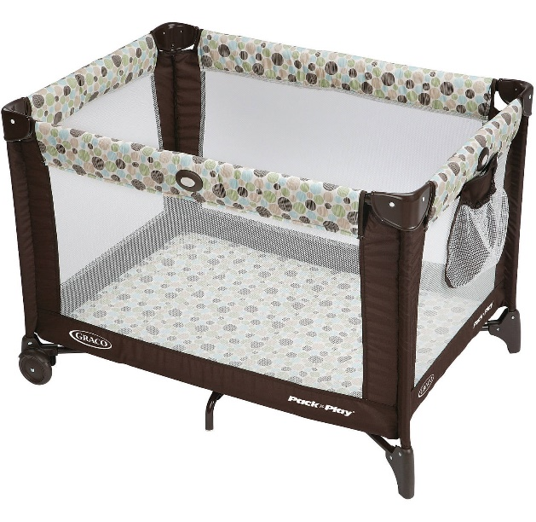

**Small Children Items**

Travelling with littles? We have them taken care of too! No need to lug heavy car seats through the airport, and no need to worry where baby is going to sleep in the RV’s. We even can add a touch of fun to eating outside, not to mention extra room for adults with our child size picnic table!

**Picnic table: $5 flat rate**

**Pack N Play: $10 flat rate**

**Car Seat: $10 flat rate**

**Booster Seat: $5 flat rate**

**Games and Movies**

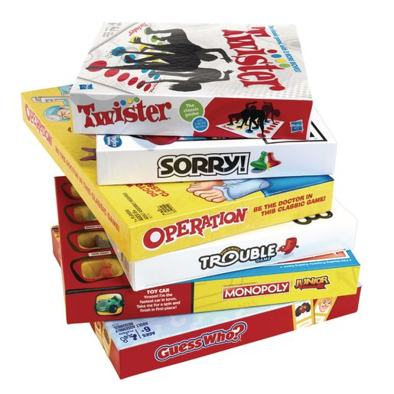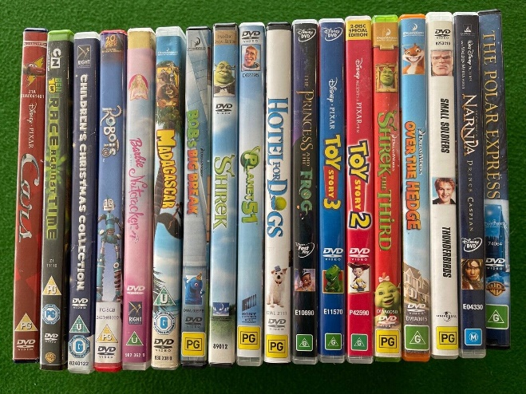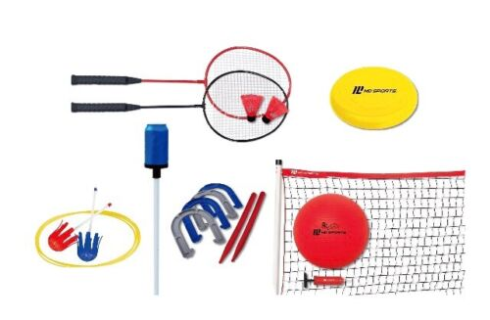

Bad weather? No worries, we offer a wide variety of family friendly movies, and board games. Good weather? Get outside and play with our array of outdoor game sets like croquet, badminton, footballs (and others), bocce ball and many more!

**Croquet set: $10 flat rate**

**Two Movies: $5 flat rate**

**Two Board Games: $5 flat rate**

**Outdoor playsets: $7 flat rate**

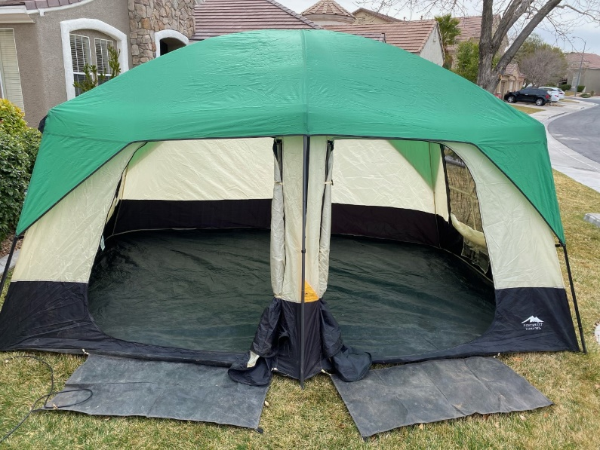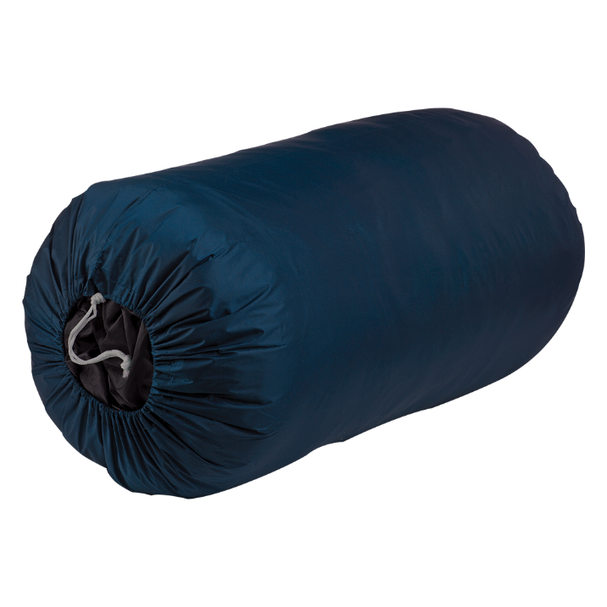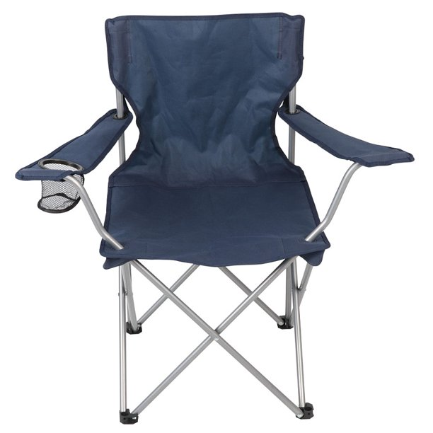

**Camping Add-Ons**

Need extra space or have guests? Why not rent our two-room 8 person tent, and allow your friends or kids to get the true camping experience. Along with our big tent, we do have a smaller 4 person tent. We also have sleeping bags and extra camping chairs for even more space and seating.

**One additional Camping Chair:** $5 (each) flat rate  
(*4 chairs come with rental*)

**Sleeping bag: $5 flat rate**

**4 person Tent: $10 flat rate**

**8 person tent: $15 flat rate**

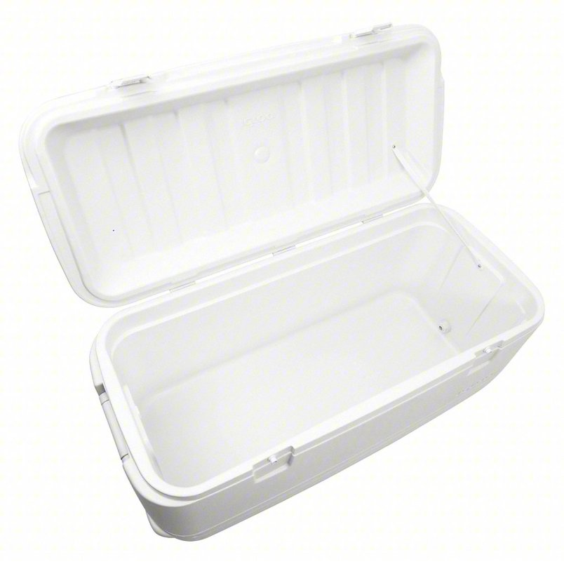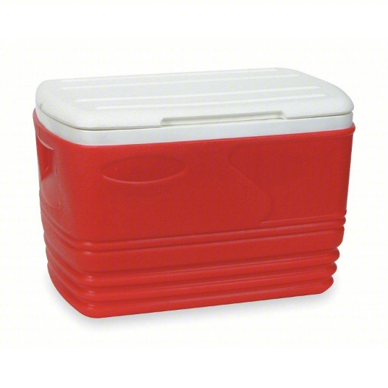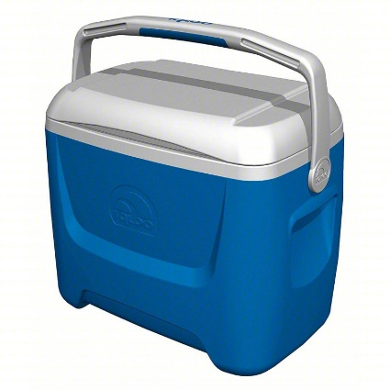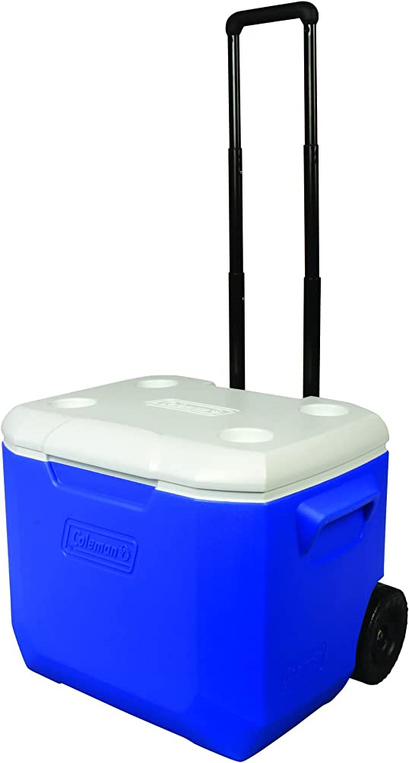

**Cooler Add-Ons**

RV refrigerators don’t always have adequate space for all your cooking needs. Why not add on a cooler to help bring along all your favorite meals and snacks. We have several sizes available.

**Large (36in x 14in x 15in): $20**

**Medium (27in x 14in x 14in): $15**

**Wheeled Small (16in x 10in x 15in): $10**

**Small (16in x 10in x 15in): $10**

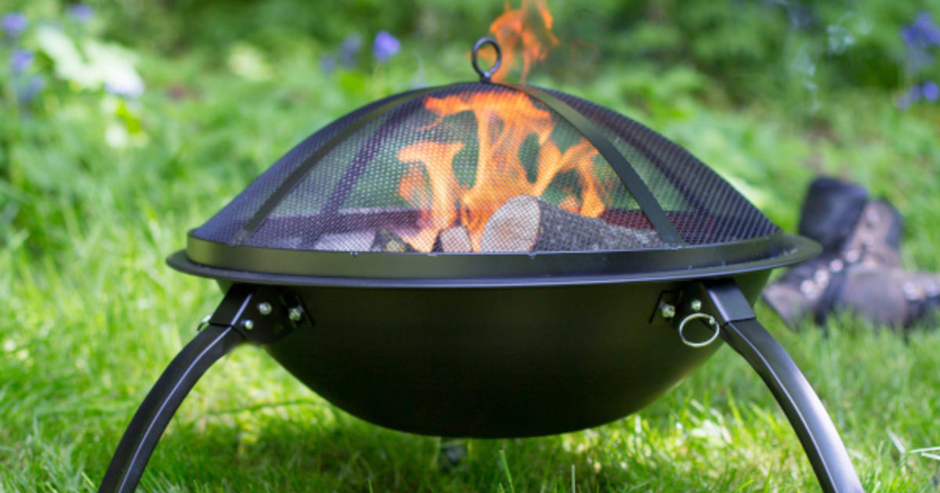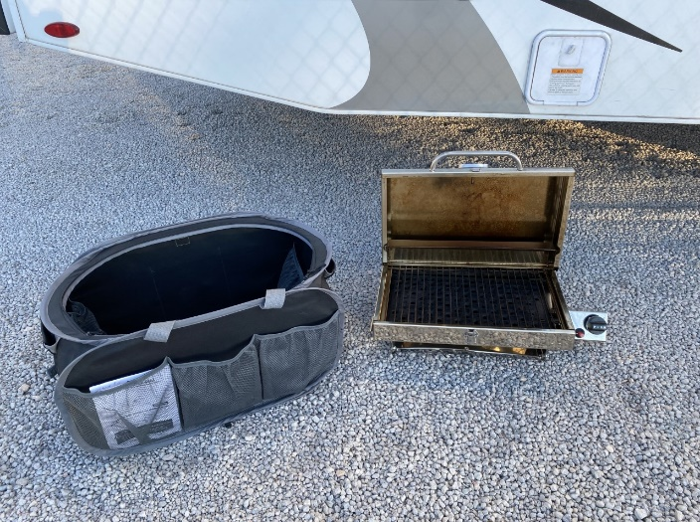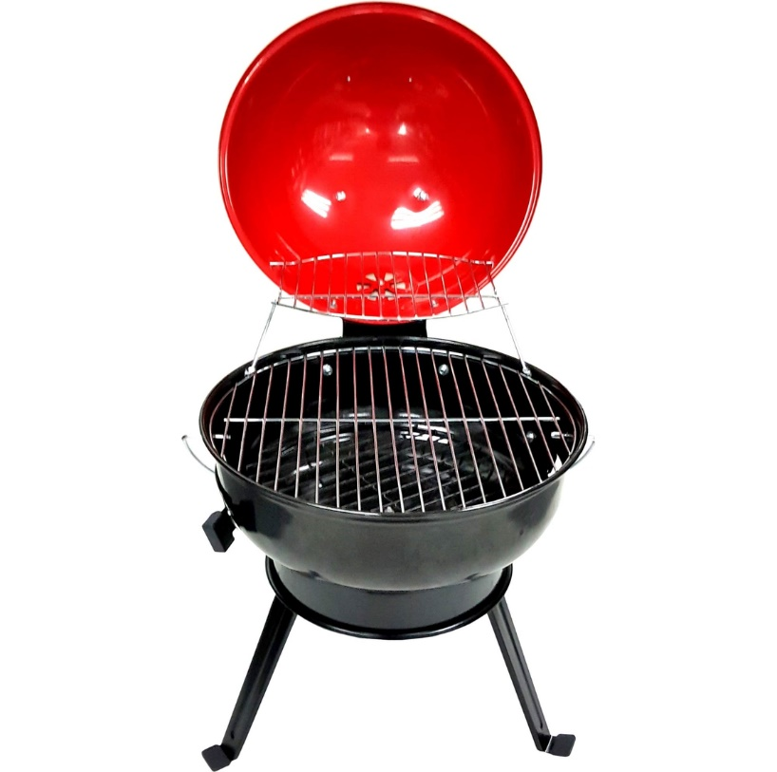

**Grilling Add-Ons**

What’s camping without camp fires and outdoor cooking. With these add on packages, you can do both! Our grill package includes: grill, a bucket of matchlight charcoal, lighter fluid and grill utensils. The fire pit package includes: Fire pit, 10 pieces of firewood, and a small axe. These items must be returned clean or there will be $20 fee for cleaning.

**Fire Pit package: $25 flat rate**

**Grill Package: $25 flat rate**

**Propane Grill: $25 flat rate (small propane tank not included)**

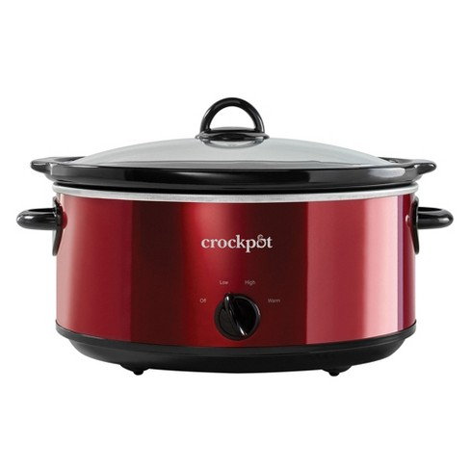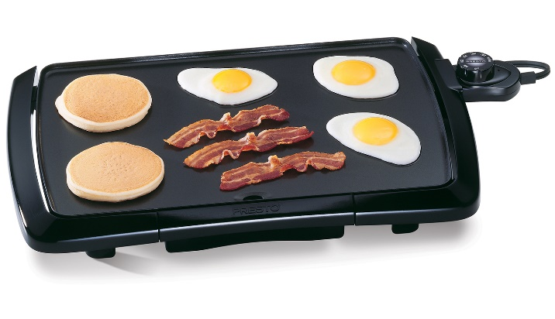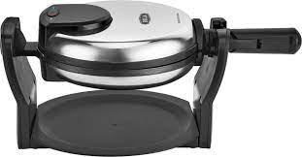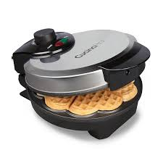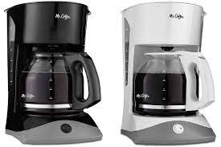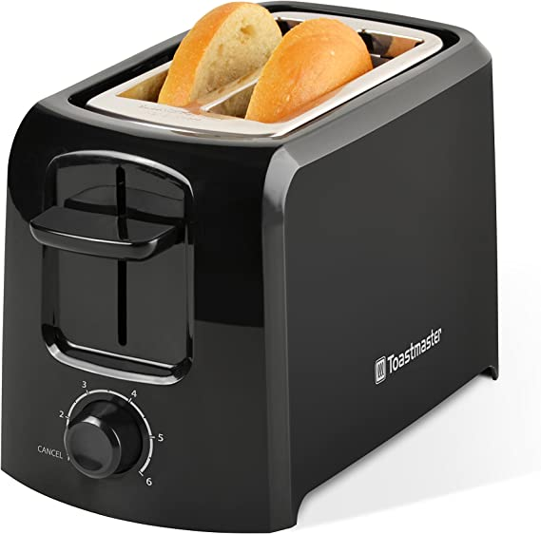

**Cooking Add-Ons**

MMM, bacon! Everyone loves the smell of bacon in the morning. These add on items allow you to have all your favorite breakfast food items including coffee! There is nothing better then prepping dinner and leaving to hike for the day and coming home to a fully cooked meal in the crock pot!

**Toaster: $5.00 flat rate**

**Coffee Pot: $5.00 flat rate**

**Electric Griddle: $5.00 flat rate**

**Crock Pot: $5.00 flat rate**

**Panini Maker: $5.00 flat rate**

**Waffle Maker: $5.00 flat rate**

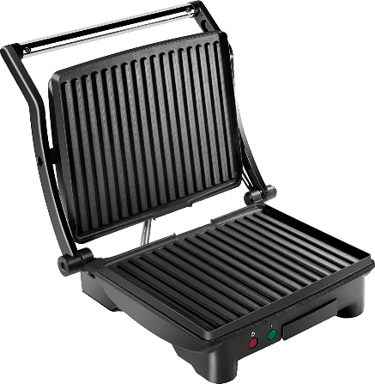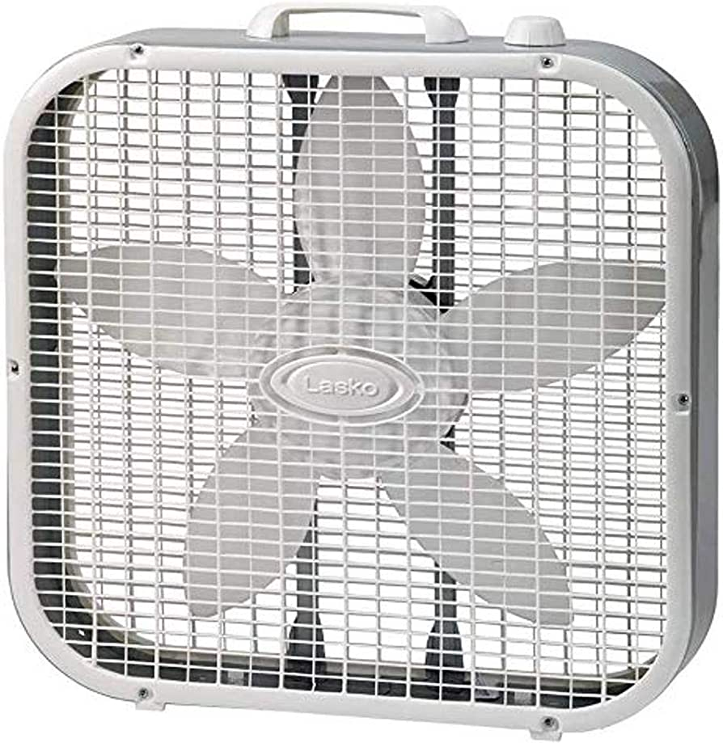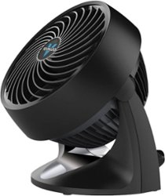

**Heat/AC Add-Ons**

When it comes to extreme weather, summer or winter. It is always nice to have a little extra help cooling down your unit or heating it up. These little add-ons, add so much to your trip! Making the inside of the RV just as enjoyable as the outside!

**Large Box Fan: $5.00 flat rate**

**Small Fan: $5.00 flat rate**

**Space Heater: $5.00 flat rate**

**Small Box Heater: $5.00 flat rate**

